CONSULTANCY SERVICES

FOR KAJIAN KES MENINGKATKAN PENGLIBATAN ANGGOTA-ANGGOTA KOPERASI DALAM MENJAYAKAN TRANSFORMASI GERAKAN KOPERASI BAGI MEMACU PERTUMBUHAN KOPERASI DI MALAYSIA

CONTRACT NO. : ................................................

BETWEEN

MALAYSIA PRODUCTIVITY CORPORATION

AND

IPSOS SDN BHD

(COMPANY NO. 912941-X)

TABLE OF CONTENTS

1.0 DEFINITIONS AND INTERPRETATIONS 6
  - Definitions 6
  - Interpretations 7
  - Entire Agreement 8
2.0 APPOINTMENT AND CONSIDERATION 8
3.0 EEFECTIVE DATE AND DURATION OF THIS AGREEMENT 9
  - Contract Period 9
  - Extension of Contract Period 10
4.0 CONSULTANT’S REPRESENTATIONS AND WARRANTIES 11
5.0 CONSULTANT’S OBLIGATIONS 12
  - Quality of Services 12
  - Timeliness of Services 12
  - Consequences of Delay 13
  - Instructions by MPC 13
  - Consultant’s Personnel 13
  - Information and Records 13
  - Liability 14
  - Indemnity 14
  - Confidentiality 15
  - Notice of Delay 16
  - Assistance in Arbitration Inquiry or Litigation 16
  - Situation Beyond Control of Consultant 17
  - Prohibition on Association 17
  - Prohibition on Conflicting Activities 17
  - Independent Consultant 17
  - Technology and Knowledge Transfer 18
  - Intellectual Property Rights 18
6.0 MPC’S OBLIGATIONS 19
  - Appointment of MPCR 19
  - Obligation to give instructions, decisions, etc. without delay 19
  - Obligation to Supply Relevant Information and Assistance 19
  - Payment to the Consultant for Services 20
  - Withholding Payment 21
7.0 MPC’S RIGHTS 22
7.1. Proprietary Rights of MPC in Relation to Documents 22
8.0 DISPUTE RESOLUTION 23
  - Dispute Resolution by Government Representative 23
  - Dispute Resolution Committee 23
  - Arbitration 24
9.0 SUSPENSION 25
  - Suspension and Resumption of Services 25
  - Extension of Time 25
  - Consequences of Mutual Termination 26
10.0 TERMINATION BY MPC 26
  - Withholding Payment 26
  - Default by the Consultant 26
  - Events of Default 27
  - Consequences of Termination by MPC 28
11.0 TERMINATION BY THE CONSULTANT 29
11.1. Consequences of Termination by the Consultant 30
12.0 TERMINATION ON NATIONAL INTEREST 31
13.0 TERMINATION ON CORRUPTION, UNLAWFUL OR ILLEGAL ACTIVITIES 32
14.0 PAYMENT UPON SUSPENSION AND TERMINATION 32
15.0 FORCE MAJEURE 33
  - Events 33
  - Notification of Force Majeure 34
  - Termination by Force Majeure 34
  - Consequences of Termination due to Event of Force Majeure 34
  - Delay 34
  - Restoration 35
  - Insurance 35
16.0 AMENDMENT 36
17.0 NOTICES 36
18.0 GOVERNING LAW 36
19.0 COMPLIANCE WITH LAWS AND REGULATIONS 36
20.0 SEVERABILITY 37
21.0 RELATIONSHIP OF THE PARTIES 37
22.0 RELATIONSHIP OF THE PARTIES 37
23.0 ADVERTISEMENT 37
24.0 TIME 37
25.0 COSTS AND STAMP DUTY 37
26.0 INCOME TAX 37
27.0 SCHEDULES AND APPENDICES 38
28.0 WAIVER 38
29.0 CUSTODY OF AGREEMENT 39
30.0 SUCCESSORS BOUND 39
SPECIAL PROVISIONS 39
SIGNATORIES TO THE AGREEMENT 40
APPENDIX 1 : TERMS OF REFERENCE 41
APPENDIX 2 : TECHNICAL DOCUMENTS FOR PROJECT IMPLEMENTATION 43
APPENDIX 3 : LETTER OF ACCEPTANCE 44
APPENDIX 4 : DELIVERABLES 45
APPENDIX 5A : SUMMARY OF TOTAL CONSULTING COST 46
APPENDIX 5B : CONSULTING FEES 47
APPENDIX 5C : OUT OF POCKET EXPENSES 48
APPENDIX 6 : SCHEDULE OF AGREED ITEMS 49
APPENDIX 7 : SERVICES IMPLEMENTATION SCHEDULE 50
APPENDIX 8 : CONSULTANT’S PERSONNEL 51
APPENDIX 9 : CONSULTANT’S PERSONNEL TIME INPUT SCHEDULE 52
APPENDIX 10 : CONSULTANT’S SERVICES TAX LICENSE 53
APPENDIX 11 : SCHEDULE OF PAYMENT 54

CONTRACT NO. : ………………… “RECITALS”
THIS AGREEMENT is made on ……………………….. ..day of ………………. …

BETWEEN

MALAYSIA PRODUCTIVITY CORPORATION, a statutory body established under the Malaysia Productivity Corporation (Incorporated) Act 1966 (Act 408), whose address is at Lorong Produktiviti, Off Jalan Sultan, 46200 Petaling Jaya, Selangor (hereinafter referred to as “MPC”) of the first part;

AND

IPSOS SDN BHD, 912941-X, a body corporate incorporated under the Companies Act 1965 having its registered office at 23rd Floor, Centrepoint North, Mid Valley City, Lingkaran Syed Putra, 59200 Kuala Lumpur., hereinafter referred to as “Consultant”) of the other part.
MPC and the Consultant shall individually be referred as the “Party” and collectively referred to as the “Parties”.

WHEREAS

- MPC is desirous of obtaining consultancy services (hereinafter referred to as “the Services”) necessary for Kajian Kes Meningkatkan Penglibatan Anggota-Anggota Koperasi Dalam Menjayakan Transformasi Gerakan Koperasi Bagi Memacu Pertumbuhan Koperasi Di Malaysia hereinafter referred to as "the Project").
- The Consultant has submitted its proposal to MPC on the scope for the Services and both Parties have agreed on the scope of Services as per the Terms of Reference specified in Appendix 1 and Technical Documents in Appendix 2 of this Agreement.

- In furtherance of such intention, MPC has agreed to appoint the Consultant and the Consultant has agreed to such appointment to provide the Services necessary for the effective implementation of the Project. A copy of the Letter of Acceptance dated 25 March 2021 is attached in Appendix 3 of this Agreement.

NOW IT IS HEREBY AGREED as follows:

PART A GENERAL

1.0 DEFINITIONS AND INTERPRETATIONS

Definitions

In this Agreement, including the appendices, unless the context otherwise requires the following words and expressions used under this Agreement shall have the following meanings:

    - “Agreement” means this document and shall comprise the clauses, schedules and appendices of this Agreement and include any supplemental written agreement thereto as may be executed and be in force from time to time or any time;

    - “Consultant” means a company incorporated under the Companies Act 1965 in Malaysia and having its registered address at 23rd Floor, Centrepoint North, Mid Valley City, Lingkaran Syed Putra, 59200 Kuala Lumpur;

    - “Contract Price” means the ceiling of total consulting fee and ceiling out of pocket expenses as specified under clause 2.0;

    - Contract Period means the contract period as prescribed under Clause
3.1 herein;

    - “Deliverables” means all deliverables (including designs, drawings, details, plans, calculations and reports) as specified in Appendix 4 to be submitted to MPC by the Consultant as particularly specified in the Terms of Reference in Appendix 1 of this Agreement;

    - “MPC’s Representative (“MPCR”) means the person under item 5 in Appendix 6 or such other person as may be appointed from time to time by MPC and notified in writing to the Consultant to carry out the duties of MPCR and the person so designated or appointed may be described by position;

    - “Services” means the professional consultancy services for the project which MPC has engaged the Consultant to perform in accordance with the Terms of Reference, Technical Documents and Deliverables as specified in Appendices 1, 2 and 4;

    - “Steering Committee” means the committee, comprising of MPC officials whose main function is to provide directions, review, consider and approve the Deliverables;

    - “Technical Committee” means the committee, comprising of MPC officials who will monitor the progress and implementation of the Services and provide input and feedback to the findings or recommendations of the Consultant.

Interpretations
In this Agreement, including the appendices/schedules/annexures, unless the context otherwise requires, the following words and phrases shall have the following meanings:

    - words denoting the singular number shall include the plural and vice versa;

    - words denoting any gender shall include all genders

    - words denoting persons shall include a body of persons, corporate or unincorporated;

    - any reference to clauses, sub-clauses, appendices, annexures, schedules, paragraphs and sub-paragraphs shall be a reference to the clauses, sub-clauses, appendices, annexures, schedules, paragraphs and sub-paragraphs of this Agreement;

    - reference to any party referred to in this Agreement shall include its successors or permitted assigns;

    - reference to any document or agreement shall include reference to such document or agreement as amended, novated, supplemented, varied or replaced from time to time;

    - reference to any legislation or any provision of any legislation shall include statutory modification and any amendment, modification or any legislation or re-enactment of that legislation or any legislative provisions substituted for, and all regulations and statutory instruments issued under such legislation or provision;

    - recital headings are for convenience only and shall not affect the interpretation and construction hereof;

    - the recitals and appendices hereto and any documents therein referred to shall be taken, read and construed as an essential and integral part of this Agreement and in the event of any inconsistency between the terms of any of the appendices and the terms of this Agreement, the terms of this Agreement shall prevail over those appendices;

    - any reference to an “amendment” includes any variation, deletion or addition and “amend” or “amended” shall be construed accordingly:
    - any reference to “design” includes technical specifications, design drawings and any other relevant documentation;

    - any reference to “law” includes any constitution, decree, judgment, legislation, order, ordinance, regulation, statute, treaty, by-law or other legislative measure in Malaysia;

    - any reference to a “day”, “week”, “month” or “year” is a reference to that day week, month or year in accordance with the Gregorian calendar;

    - if any period of time is specified from a given day or a day of a given act or event, it is to be calculated exclusive of that day and if any such specified period of time or a day of a specified given act or event falls on a day which is not a Working Day, then such period of a specified time or a specified day of a given act or event is deemed to be on the next Working Day;

    - any reference to “pay” or its cognate expressions includes payment made in cash or by way of bank draft (drawn on a bank licensed to carry on banking business under the provisions of the Financial Services Act 2013 [Act 758] and Islamic Financial Services Act 2013 [Act 759]) or effected through inter-bank transfers to the account of the payee giving the payee immediate access to available funds; and

    - the recitals and appendices hereto and any documents therein referred to shall be taken, read and construed as an essential and integral part of this Agreement and in the event of any inconsistency between the terms of the appendices and the terms of this Agreement, the terms of this Agreement shall prevail over those appendices.

Entire Agreement

This Agreement contains the entire agreement between the Parties with respect to the subject matter hereof and supersedes all prior agreements or understandings, between the Parties in relation to such matter. The Parties hereby acknowledge that in entering into this Agreement, it has not relied on any representation or warranty save as expressly set out herein or in any document expressly referred to herein.

2.0 APPOINTMENT AND CONSIDERATION

MPC hereby appoints the Consultant and the Consultant accepts the appointment to provide the Services for a consideration of Ringgit Malaysia Thirty-nine thousand four hundred ninety-five and sixty cents only (RM39,495.60) as the ceiling contract amount (hereinafter referred to as the “Contract Price” and specified in Appendix 5A of this Agreement) which consists of Ringgit Malaysia Thirty-nine thousand four hundred ninety-five and sixty cents only (RM39,495.60) as the ceiling consulting fee (as specified in Appendix 5B of this Agreement) and Ringgit nil only (RM0.00) as the ceiling out of pocket expenses (as specified in Appendix 5C of this Agreement) subject to the terms and conditions set forth in this Agreement as per the Letter of Acceptance dated 25 March 2021 (as specified in Appendix 3 of this Agreement).

3.0 EEFECTIVE DATE AND DURATION OF THIS AGREEMENT

Contract Period

This Agreement shall be for a period of three (3) months as specified under item 2 in Appendix 6 (hereinafter referred to as the “Contract Period”) commencing from 25 March 2021(hereinafter referred to as “Commencement Date”) and shall expire on the date stated under item 3 in Appendix 6 (hereinafter referred to as the “Contract Expiry Date”) unless terminated earlier in accordance with the provisions of Part E of this Agreement.

Extension of Contract Period

The Consultant shall, upon it becoming reasonably apparent that the progress of the Services is delayed, apply in writing to MPC for the approval of extension of the Contract Period. The Consultant shall further furnish to MPC relevant information as to the causes of delay together with a revised Services Implementation Schedule and estimated revised cost (if any), for the approval of MPC.

MPC shall have the absolute discretion whether or not to consider such application. In the event MPC agrees to extend the Contract Period, MPC shall inform the CA in writing pertaining to the period of extension. Provided that the extension on the Contract Period shall not affect the Contract Price as specified in clause 2.0.

PART B

CONSULTANT’S REPRESENTATIONS, WARRANTIES AND OBLIGATIONS

CONSULTANT’S REPRESENTATIONS AND WARRANTIES

The Consultant hereby represents and warrants to MPC that –

    - it is a corporation validly existing under the laws of Malaysia;

    - it is registered as a consultancy firm with the Ministry of Finance Malaysia (MOF);

    - the Consultant shall keep current all such registrations and ensure their validity throughout the duration of this Agreement;

    - the Consultant has the legal capacity to enter into and perform its obligations under this Agreement and to carry out the Services as contemplated by this Agreement;

    - the Consultant has taken all necessary actions to authorize the entry into and performance of this Agreement and to carry out the Services contemplated by this Agreement;

    - as at the execution date, neither the execution nor performance by the Consultant of this Agreement nor any transactions contemplated by this Agreement will violate in any respect any provision of –

      - its Memorandum and Articles of Association; or

      - any other document or agreement which is binding upon it or its assets;

    - no litigation, arbitration, tax claim, dispute or administrative proceeding is presently current or pending or, to its knowledge, threatened, which is likely to have a material adverse effect upon it or its ability to perform its financial or other obligations under this Agreement;

    - no corruption or unlawful or illegal activities or practices have been used to secure this Agreement;

    - this Agreement constitutes a legal, valid and binding obligation of the Consultant and is enforceable in accordance with its terms and conditions;

    - it has the necessary financial, technical, and professional capability and expertise to provide the Services under this Agreement,

and the Consultant acknowledges that MPC has entered into this Agreement in reliance on its representations and warranties as aforesaid.

5.0 CONSULTANT’S OBLIGATIONS

Quality of Services

    - The Consultant shall maintain a professional standard of service and competence and shall exercise all reasonable skill, care and diligence in the discharge of the professional services agreed to be performed under this Agreement in the best interests of MPC and, in so far as their duties are discretionary, shall act fairly between MPC and any third party.

    - The Consultant shall have sufficient knowledge of the project and other regulations relating to the project, and shall advice MPC accordingly in matters affecting the implementation of the project.

Timeliness of Services

    - The Consultant shall prepare a draft services implementation schedule incorporating the key dates specified for carrying out the Services which shall be in accordance with the requirements of the Terms of Reference, for the approval of MPC.

    - The agreed draft service implementation schedule as approved by MPC shall be the Service Implementation Schedule as in Appendix 7; which shall be amended only with the approval of MPC. Any subsequent changes or amendments approved by MPC shall form part and be read together with the Service Implementation Schedule.

    - The Consultant shall provide MPC scheduled progress reports in such form and details as prescribed in the Terms of Reference.

    - The Consultant shall undertake to provide status updates through reports and presentations relevant to the Services as required by MPC and attend all deliberations and meetings of the Technical Committee and Steering Committee.

    - The Consultant shall take remedial action as advised by the Technical Committee and Steering Committee as deemed appropriate and shall prepare the final reports, incorporating the issues raised for the consideration and approval of the Steering Committee.

Consequences of Delay

    - If the Consultant fails to deliver any Deliverables by the due date(s) agreed by both parties as specified in Appendix 4 of this Agreement without reasonable cause, the Consultant shall pay Liquidated and Ascertained Damages (LAD) to MPC for the delay. The period of delay shall be calculated beginning from the scheduled delivery date and ending on the actual date as delivered and submitted to MPC.

    - The LAD shall be computed on a daily basis for each day of delay at every stage of deliverables based on the formula specified under item 10 in Appendix 6 of this Agreement.

Instructions by MPC

    - The Consultant shall comply with all instructions issued by MPC in regard to matters expressly empowered under this Agreement. The Consultant shall follow MPC procedures so far as possible and shall obtain prior approval in writing from MPC of any departures from such procedures. Nothing in this clause shall be deemed to affect the responsibilities of the Consultant in connection with the Services.

    - The Consultant shall attend or be represented at all meetings convened by MPC to which the Consultant may be summoned, and shall advise and assist MPC on all matters relating to the Services.

Consultant’s Personnel

    - The Consultant shall provide efficient, suitably qualified and experienced Personnel and acceptable to MPC to carry out the Services.

    - The Services shall be carried out by the Consultant’s Personnel as specified under Appendix 8 hereof within the time and stage as specified in the Service Implementation Schedule in Appendix 7.

    - The Project Manager of the Consultant as specified in Appendix 8 shall be responsible for the management of the Consultant’s Personnel for the Services as well as to act as liaison between the Consultant and MPC.

    - The Consultant shall ensure the Personnel are dedicated to the Services and give priority to the performance of their respective portions of the Services assigned to them over any other works, tasks and assignments in relation to other existing or future projects.

    - No Personnel shall be engaged by the Consultant or its affiliates for other work or project without the prior written consent of MPCR.

- There shall be no changes or substitutions in the Consultant’s Personnel set forth in Appendix 8 without the prior written approval of MPC. If for any reason beyond the reasonable control of the Consultant, it becomes necessary to replace any of the Consultant’s Personnel, the Consultant shall forthwith provide as a replacement, a person of equivalent or better qualification and experience to MPC at no additional cost to MPC of which MPC shall consider without undue delay.

- No Personnel shall be engaged by the Consultant or its affiliates for other work or project without the prior written consent of MPCR.

- In the event the number of Consultant’s Personnel as specified in Appendix 8 is reduced without the prior written approval of MPC, MPC shall have the right to deduct the Consulting Fee based on Consultant’s Personnel Time Input Schedule as specified in Appendix 9.

- The Consultant shall ensure that any changes, substitution or replacement of Personnel shall not affect the term and the implementation for the provision of the Services.

- Notwithstanding clause 5.5(f), MPCR may at any time request the Consultant to reduce the number of the Personnel according to the progress of the Works.

- MPCR may with the agreement of the Consultant, direct the Consultant, within a time frame of not less than fourteen (14) days, to remove any Personnel who, in the opinion of MPCR, is lacking in appropriate skills or qualifications, engages in misconduct or is incompetent or negligent.

Information and Records

    - The Consultant shall furnish MPC such information in relation to the Services as MPC may from time to time reasonably request.

    - The Consultant shall keep accurate, systematic and up-to-date records and accounts in respect of the provision of the Services in such form and details as is customary in the profession or as may be required by MPC from time to time as shall be sufficient to establish accurately that the costs and expenditure referred to in Appendix 5A, Appendix 5B and Appendix 5C of this Agreement have been duly incurred.

    - The Consultant shall permit MPCR from time to time to inspect their records and accounts relating to the Services and to make copies thereof and shall permit MPC or any person authorized by MPC, from time to time, to audit such records and accounts during the performance of the Services.

    - In the event of failure occurring after the completion of the Project, the Consultant may be required by MPC to submit a report detailing probable cause and remedial action. References shall be made to all kept records and accounts.

Liability

The Consultant agrees that it shall provide the Services under this Agreement in good faith and hereby warrants that the Services provided under this Agreement meet the professional standards for consultancy in the relevant field.

Indemnity

The Consultant agrees with MPC that –

    - the Consultant shall perform all of its obligations under this Agreement at its own risk and releases, to the fullest extent permitted by law, and shall indemnify and keep MPC and their agents and servants from all claims and demands of every kind resulting from any accident, damage, injury or death arising from carrying out of the Services except where such accident, damage, injury or death is caused or contributed to by any act or omission or negligence of MPC or its agents and servants and the Consultant expressly agrees that in the absence of any such act, omission or negligence as aforesaid MPC shall have no responsibility or liability whatsoever in relation to such accident, damage, injury or death.

    - the Consultant shall indemnify and keep MPC indemnified from and against all actions, suits, claim or demands, proceedings, losses, damages, compensation, costs (legal cost) charges and expenses whatsoever to which MPC shall or may be or become liable in respect of or arising from

      - the negligent use or act, misuse or abuse by the Consultant or the Consultant’s Personnel, servants, agents or employees appointed by the Consultant in the performance of the Services; or

      - any loss or damage to property or injury of whatsoever nature or kind and howsoever or wherever sustained or caused or contributed to by carrying out the Services by the Consultant to

any person and not caused by the negligence or willful act, default or omission of MPC, its agents or servants; or

      - any loss, damage or injury from any cause whatsoever to property or persons affected by the Services to the extent to which the same is occasioned or contributed to by the act, error, omission, neglect, breach or default of the Consultant or the Consultant’s Personnel, servants, agents or employees; and

    - the obligations under this clause shall continue after the expiry or earlier termination of this Agreement in respect of any act, deed, matter or thing happening before such expiration or termination of this Agreement.

Confidentiality

    - Except with the prior written consent or the instructions of MPC, the Consultant shall not at any time communicate to any person or body or entity any confidential information disclosed to the Consultant for the purpose of the provision of the Services or discovered by the Consultant in the course of this provision and performance of the Services; nor make public any information as to the recommendations, assessments and opinions formulated in the course of or as a result of the provision and performance of the Services; nor make or cause to be made any press statement or otherwise relating to the Services; nor make use of the Deliverables for the purposes other than that stipulated in this Agreement and the foregoing obligations shall not be rendered void by suspension, termination or expiry of this Agreement for whatsoever cause.

    - This sub-clause shall not apply to information which:

      - is or becomes generally available to the public other than as a result of a breach of an obligation under this clause;

      - is already known to the other party to whom it is disclosed to, at the time of disclosure;

      - is independently developed without benefit of the confidential information of the other party;

      - is in possession of the Consultant without restriction before the date of receipt from the other party subject to the right of MPC to re-classify certain information as confidential.

    - In the event that the Consultant receives a request to disclose all or any part of any confidential information under the terms of a valid and effective subpoena or order issued by a court of competent jurisdiction, judicial or administrative agency or by a legislative body or committee,

such disclosure by the Consultant shall not constitute a violation of this Agreement provided that•

      - the Consultant promptly notifies MPC of the existence, terms and circumstances surrounding such request;

      - the Consultant consults with MPC on the advisability of taking available legal steps to resist or narrow, such request; and

      - the Consultant exercises its best efforts to obtain an order or other reliable assurance that confidential treatment shall be accorded to the information to be disclosed.

    - This clause continues in force notwithstanding the termination of this Agreement for any reason.

Notice of Delay

In the event the Consultant encounters any delay in obtaining the required assistance and information set forth in clause 5.6(a), the Consultant shall notify MPC of such delay and its duration and MPC, at its absolute discretion, may grant an appropriate extension of time and other consideration appropriate for provision of the Services.

Assistance in Arbitration Inquiry or Litigation

The Consultant shall, if so required by MPC, within the period of work before completion, assist and advise MPC with regard to any matter or thing which may be the subject of arbitration, inquiry or litigation and if and when so required by MPC shall attend and give evidence or otherwise assist MPC before any court or in any arbitration or at any inquiry dealing with any matter arising from or in connection with the execution of the Services. In the event of arbitration or other proceedings arising after the completion of Services, if so required by MPC, the Consultant shall assist in any manner whatsoever and advise MPC under the same conditions of engagements as are applicable generally to this Agreement, subject always to −

    - the right of the Consultant to recover its time and cost in attending to this request, such time and cost to be negotiated separately with MPC; and

    - the right of the Consultant to take appropriate measures to safeguard and protect its interest.

Situation Beyond Control of Consultant

    - The Consultant shall immediately inform MPC in writing of any situation or the occurrence of any event beyond the reasonable control of the Consultant, which makes it impossible for the Consultant to carry out its obligations hereunder.

    - If MPC agrees in writing that such situation or event exists, MPC may terminate this Agreement by giving not less than thirty (30) days written notice and shall pay all fees and payments due and outstanding to the Consultant in accordance with clause 14.0 within thirty (30) days from the date of termination of this Agreement.

    - In the event of disagreement between the Parties as to the existence of such situation or event, the matter shall be referred to the GR as specified under item 5 in Appendix 6 for a decision.

Prohibition on Association

The Consultant agrees that during and after the conclusion or termination of this Agreement, the Consultant shall limit its role for the Project to the provision of the Services and hereby disqualifies itself from the provision of goods or services in any capacity for the Project including bidding for any part of the Project except as MPC may otherwise agree or request the Consultant.

Prohibition on Conflicting Activities

No Personnel of the Consultant assigned to the Services under this Agreement nor the Consultant’s staff, subsidiary or associate shall engage, directly or indirectly, either in his name or through his then employer, in any business or professional activities connected to the Services or Project and neither shall the Consultant’s Personnel be so engaged directly or indirectly, either in his name or through the Consultant in any such other conflicting business or professional activities.

Independent Consultant

Nothing contained herein shall be construed as establishing or creating between MPC and the Consultant the relationship of master and servant or principal and agent. The position of the Consultant performing the Services is that of an independent consultant.

Technology and Knowledge Transfer

    - If the Consultant appoints foreign professionals, the Consultant shall endeavour to ensure that the employees of MPC are trained or exposed to the expertise of such foreign professionals pursuant to a programme for technology and knowledge transfer.

    - The Consultant shall allow the employees of MPC to be involved in the study and implementation of the Project commencing from the Commencement Date of this Agreement until the Contract Expiry Date.

Intellectual Property Rights

    - Any intellectual property rights arising out of design, plans, calculations, drawings, developed or used for or incorporated in the Services shall vest in and become the sole property of MPC free and clear of all liens, claims and encumbrances. The Consultant shall not during or at any time after completion on the Services or after the expiry or termination of this Agreement, in any way, question or dispute the ownership of MPC.

    - The Consultant agrees to grant to MPC free from all royalties, fees and other charges, all licenses in respect of intellectual property rights now or hereafter owned or controlled by the Consultant or in respect of which the Consultant has or will have the right to grant licenses of any design, plans, calculations, drawings, developed or used for or incorporated in the Services or any part thereof.

    - The Consultant shall defend and indemnify MPC from and against all claims, costs, damages, charges and proceedings whatsoever for or on account of infringement of any intellectual property rights in respect of any design, plans, calculations, drawings, documents, plant, equipment, machinery, material, methods or processes developed or used for or incorporated in the Services except where such infringement results from compliance with MPC’s instructions in accordance with this Agreement.

    - Where any infringement results from compliance with MPC’s instructions in accordance with this Agreement, any royalties, damages or other monies which the Consultant may be liable to pay to the persons entitled to such intellectual property rights shall be reimbursed by MPC.

PART C

MPC’S RIGHTS AND OBLIGATIONS

6.0 MPC’S OBLIGATIONS

Appointment of MPCR

    - MPC shall appoint the person under item 5 in Appendix 6 of this Agreement or other persons from time to time as MPC Representative (“MPCR”) to carry out its obligations and to exercise its right under this Agreement, and MPCR shall have the power to carry out such obligations and exercise such rights on behalf of MPC, except for the provisions under clause 10.0, 12.0 and 13.0 which are expressly reserved to the officer authorized as named in the signatories to this Agreement or any other officer authorized under section 2 of MPC Contracts Act 1949 [ Revised 1973].

    - The Consultant shall comply with all instructions issued by MPCR in regard to matters expressly empowered to MPCR to issue under this Agreement.

Obligation to give instructions, decisions, etc. without delay

    - All instructions, notifications, consent or approval issued by MPCR shall be in writing. However, MPCR may, where necessary issue oral instructions, notifications, consent or approvals and such oral instructions, notifications, consents or approvals shall be followed in writing not later than seven (7) days thereafter.

    - If the Consultant requires a decision from MPC for the performance of its Services under this Agreement, the Consultant shall submit its request in writing to MPCR shall give its decision within the period stipulated under item 6 in Appendix 6 of this Agreement.

Obligation to Supply Relevant Information and Assistance

    - The Consultant may request all the necessary and relevant information which are in the possession of MPC required for purposes of carrying out of its Services under this Agreement. Notwithstanding the request, MPC shall have the discretion to supply the necessary information it deems relevant.

    - Any necessary and relevant information supplied by MPC to the Consultant pursuant to clause 6.3(a) of this Agreement shall not

relieve the Consultant of any of the Consultant’s obligations under this Agreement.

    - MPC gives no warranty in any manner whatsoever for the data, report, map, photograph, plan, drawing, record or other information either as to the accuracy or sufficiency or as to how the same should be interpreted and the Consultant, when he makes use of and interprets the same, shall do so entirely at his own risk and it shall not constitute a breach of obligation on the part of MPC under clause 6.3(a) of this Agreement if such data, report, map, photograph, plan, drawing, record or information is not accurate or sufficient for the purpose of performing the Consultant's obligation under this Agreement.

    - Where necessary, MPC shall assist the Consultant to obtain, free of charge, unimpeded access to all land in respect of which access is required for the performance of the Services. MPC shall not be responsible for any damage to such land or any property thereon resulting from such access.

Payment to the Consultant for Services

    - the Contract Price consist of the fixed ceiling consulting fee as specified in Appendix 5B (“Fixed Ceiling Consulting Fees”) and the ceiling out of pocket expenses as specified in Appendix 5C (“Ceiling Out of Pocket Expenses”). If the actual costs incurred in the performance of the Services does not exceed the Fixed Ceiling Consulting Fee and the Ceiling Out Of Pocket Expenses, downward adjustments can be made in accordance with Appendix 5A, Appendix 5B and Appendix 5C. The payment shall include amongst others MPC Service Tax, which amount shall be paid by MPC to the Consultant upon the Consultant giving proof of the registration of the Service Tax Act 2018 with the Royal Customs Department of Malaysia. A copy of the registration of Government Service Tax with the Royal Customs Department of Malaysia is attached in Appendix 10 of this Agreement.

    - Payments under this Agreement shall be made progressively in stages/phases in accordance with the Schedule of Payment as in Appendix 11 upon the Consultant furnishing to MPC all relevant drawings, design, reports, records and data when submitting request for payment.

    - Payment to the Consultant shall be made within thirty (30) days upon receiving the proper invoices, vouchers and other appropriate supporting materials from the Consultant and be deposited to the account of the Consultant as specified under item 7 in Appendix 6.

    - If any item or part of an item of an account/claims/invoices rendered by the Consultant is reasonably disputed or reasonably subject to question by MPC, MPC shall within thirty (30) days after receipt of the invoice by MPCR inform the Consultant in writing of all items under dispute or subject to question. Payment by MPC of the remainder of the invoice shall not be withheld on such grounds.

    - Except as otherwise agreed between MPC and the Consultant, payments in respect of all fees and expenses incurred by the Consultant shall be made in Ringgit Malaysia.

    - If the Consultant intends to claim any additional payment pursuant to any clause of this Agreement, the Consultant shall within ninety (90) days of the occurrence of such event or circumstances or instructions give notice in writing to MPCR of its intention for such claim and submit full particulars of the claims together with supporting documents, for the approval of MPC. If the Consultant fails to comply with this clause, the Consultant shall not be entitled to such claim and MPC shall be discharged from all liability in connection with the claim.

    - Final payment of the Contract Price shall be made only after the final Deliverables and a final account, identified as such, have been submitted by the Consultant and approved as satisfactory by MPC. Any amount which MPC has paid or caused to be paid in excess of the costs actually incurred shall be reimbursed by the Consultant to MPC within thirty (30) days after receipt by the Consultant of notice thereof.

Withholding Payment

    - MPC may by giving written notice to the Consultant, and without prejudice to any other rights MPC may have under this Agreement, withhold payments to the Consultant under this Agreement, upon the occurrence and continuance of any of the following events:

      - the Consultant commits any breach of the terms and conditions of this Agreement; or

      - the progress of the Services fails to measure up to the aggregate payment made to date; or

      - any other condition which has arisen, which in the opinion of MPC, interferes or threatens to interfere with the successful carrying out of the Project or the accomplishment of the purposes of this Agreement; or

      - any failure of the Consultant to deliver the Services to the satisfaction of MPC.
    - The Consultant may apply to MPC, within fourteen (14) days after receiving notice referred to in clause 6.5 (a) to review the decision to withhold payments by submitting documents and other evidence to substantiate its claims that the Services is compatible to the payments received. MPC’s decision on the application shall be final and conclusive.

7.0 MPC’S RIGHTS

Proprietary Rights of MPC in Relation to Documents

    - All reports and relevant data such as plans, statistics and supporting records or material compiled or prepared by the Consultant in the course of this Agreement shall be the absolute property of MPC throughout their preparation and at all times thereafter. MPC shall have the sole and exclusive right, title and ownership to the documents.

    - The Consultant shall deliver all the plans, statistics and supporting records or material compiled or prepared in the course of this Agreement to MPC upon the Contract Expiry Date or earlier termination of this Agreement. The Consultant shall not use any information in the documents for purposes unrelated to this Agreement without the prior written consent of MPC save and except where the same is required by law or any other regulatory authority or for the purposes of the Consultant’s quality performance review processes.

    - The Consultant shall not publish alone or in conjunction with any other person any articles, photographs or other illustration relating to the Services unless with the prior written consent of MPC.

    - MPC reserves the right to make use of all documents including drawings and specifications relating to the Services at any time and for any purpose it so wishes.

PART D DISPUTE RESOLUTIONS

8.0 DISPUTE RESOLUTION

Dispute Resolution by MPC Representative

    - Any dispute between the Parties in respect of any matter under this Agreement (except in relation to MPC exercising its sole discretion under this Agreement) which are not capable of being amicably resolved between the Parties may be referred to the appointed MPCR.

    - MPCR who is appointed for such purposes shall undertake to resolve such dispute with all fairness and endeavor to achieve the best possible solution for the Parties.

    - If the Consultant:

      - fail to receive a decision from MPCR within seven days (7) days after being requested to do so; or

      - is dissatisfied with any decision of MPCR.

then such dispute or difference shall be referred to Dispute Resolution Committee within fourteen days (14) days.

Dispute Resolution Committee

    - Any dispute between the Parties in respect of any matter under this Agreement (except in relation to MPC exercising its sole discretion under this Agreement) may be referred to a dispute resolution committee (hereinafter referred to as the “Dispute Resolution Committee"), comprising –

      - Head of Department as the Director General;

      - one (1) representative to be appointed by MPC; and

      - one (1) representative appointed by the Consultant.

    - The Dispute Resolution Committee shall determine its own procedures. The Dispute Resolution Committee shall meet and endeavor to achieve an amicable settlement between the Parties in respect of any matter referred to it.

Arbitration

    - If any matter, dispute or claim which is referred to the Dispute Resolution Committee cannot be agreed by the relevant Parties within forty five (45) days after the date of referral, then such dispute or difference shall be referred to arbitration within forty-five (45) days to an arbitrator to be agreed between the Parties and failing such agreement, to be appointed by the Director of the Kuala Lumpur Regional Centre for Arbitration on the application of either Party hereto. Such arbitration shall be heard at the Kuala Lumpur Regional Centre for Arbitration and shall be conducted in accordance with the rules for arbitration of the Kuala Lumpur Regional Centre for Arbitration using the facilities and the system available at the Centre.

    - Such reference shall not be commenced until after the completion or alleged completion of the Project or determination or alleged determination of the Consultant’s employment under this Contract, or abandonment of the Project, unless with the written consent of MPC and the Consultant.

    - In the event that such consent has been obtained in accordance with clause 8.3(b), the reference of any matter, dispute or difference to arbitration pursuant to this clause and/or the continuance of any arbitration proceedings consequent thereto shall in no way operate as a waiver of the obligations of the parties to perform their respective obligations under this Agreement.

    - Upon every or any such reference the costs of such incidental to the reference and award shall be in the discretion of the Arbitrator who may determine the amount thereof, or direct the amount to be taxed as between solicitor and client or as between party and party, and shall direct by whom and to whom and in what manner the same be borne, award and paid.

    - The award of the Arbitrator shall be final and binding on the Parties.

    - In the event of the death of the arbitrator or his unwillingness or inability to act, then MPC and the Consultant upon agreement shall appoint another person to act as the arbitrator, and in the event MPC and the Consultant fail to agree on the appointment of an arbitrator, an arbitrator shall be appointed by the Director of the Kuala Lumpur Regional Centre for Arbitration.

    - this clause, “reference” shall be deemed to be reference to arbitration within the meaning of the Arbitration Act 2005.

    - The arbitration shall be governed by the Arbitration Act 2005 and the laws of Malaysia.

PART E SUSPENSION AND TERMINATION

9.0 SUSPENSION

Suspension and Resumption of Services

    - MPCR may at any time instruct the Consultant to suspend part or all of the Services by the giving the Consultant due notice in writing.

    - Upon receipt of such instruction, the Consultant shall suspend part or all of the Services for such time and in such manner as specified in the instruction and shall duly protect, store and secure the Services against any deterioration, loss or damage.

    - During the suspension period, the Consultant shall continue to perform his obligations under the Agreement which is not affected by the instruction to suspend, including the obligation to effect and maintain insurance.

    - MPCR may instruct the Consultant to resume the Services at any time thereafter. Upon receipt of such instruction the Consultant shall resume the Services and the Parties shall jointly examine the Services affected by the suspension. The Consultant shall make good any deterioration or defect in or loss of the Services which has occurred during the suspension. The Consultant shall also take all necessary actions to mitigate the expenses incurred.

Extension of Time

    - If the Consultant suffers delay and/or incurs expenses in complying with the instruction under clause 9.1 and in resumption of the Services, and if such delay and/or expenses was not foreseeable by the Consultant, the Consultant shall give notice for extension of time. PROVIDED THAT the Consultant shall not be entitled to such extension if the suspension is due to a cause attributable to the Consultant and the Consultant shall not be entitled to payment of loss and expenses if the Consultant−

      - fails to take measures specified in clause 9.1(b); and

      - fails to take all necessary action to mitigate the expenses incurred.

    - In the event such suspension shall continue for a period of more than twelve (12) months, the Parties shall then discuss whether to mutually terminate the Agreement or suspend the Services for a further period.

Consequences of Mutual Termination

    - If this Agreement is mutually terminated under this clause-

      - clause 11.1 (b) shall apply; and

      - payment obligations including all costs and expenditure incurred by MPC and the Consultant shall be ascertained in accordance with clause 14.

10.0 TERMINATION BY MPC

Withholding Payment

If any of the conditions referred to in clause 6.5(a) shall have happened and be continuing for a period of fourteen (14) days after MPC has given written notice of withholding of payments to the Consultant under this Agreement, MPC may by written notice to the Consultant terminate this Agreement.

Default by the Consultant

    - In the event the Consultant without reasonable cause −

      - suspends the implementation of the Services;

      - fails to proceed regularly and diligently with the performance of its obligations under this Agreement;

      - fails to execute the Services in accordance with this Agreement ;

      - persistently neglects to carry out its obligations under this Agreement;

      - defaults in performing the duties under this Agreement; or

      - breaches any of its obligations or fails to comply with any other terms and conditions of this Agreement,

(hereinafter referred to as the “Consultant Default”), then MPC shall give notice in writing (hereinafter referred to as the “Default Notice”) to the Consultant specifying the default and requiring the Consultant to remedy such defaults within fourteen (14) days from the date of issuance of the Default Notice (hereinafter referred to as the “Remedy Period”. If the Consultant fails to remedy the relevant default within such period or such other period as may be determined by MPC, MPC shall have the right to terminate this Agreement at any time thereafter by giving notice to that effect to the Consultant.

Events of Default

    - If at any time during the Contract Period•

      - the Consultant goes into liquidation or a receiver is appointed over

      - the Consultant goes into liquidation or compounds with or enter into an arrangement or compositions with its creditors;

      - an order is made or resolution is effectively passed for winding up of the Consultant (except for the purpose of restructuring or amalgamation with the written consent of MPC, which consent shall not be unreasonably withheld);

      - a provisional liquidator, receiver or manager of its business or undertaking is appointed, or possession taken by or on behalf of the creditors or debenture holders secured by a floating charge of any property comprised in or subject of the said floating charge over the assets of the Consultant; or

      - execution is levied against a substantial portion of the Consultant’s assets; or

      - the Consultant assigns the whole or any part of this Agreement; or

      - the Consultant did not obtain prior written approval from MPC for any sale or transfer of company’s equity throughout the contract period;

      - any of the CA’s director is prosecuted for any offences; or

      - any other condition which has arisen, which in the opinion of MPC, interferes or threatens to interfere with the successful carrying out of the Services or the accomplishment of the purposes of this Agreement,

then MPC shall have the right to terminate this Agreement forthwith by giving notice to that effect.

Consequences of Termination by MPC

    - Upon termination of this Agreement under clause 10.1, 10.2 or 10.3 the powers and rights granted by MPC to the Consultant and the obligations in this Agreement shall terminate immediately.

    - The Consultant shall hence forth –

      - cease all the Services immediately;

      - submit to MPC the detailed reports of the costs of the Services and other payments which has become due and owing from MPC prior to the termination for verification and approval by MPC;

      - forthwith, at its own costs and expense, vacate and remove from the Project Management Team’s office any equipment, machineries and materials belonging to the Consultant, its Personnel, employees, servants and agents and make good all damage caused by such removal or such detachment;

      - at no cost, hand over all plans, drawings, reports, records, documents, specifications and similar materials to MPC save and except its own working papers and archival copy of any advice, reports or opinion of which are retained to support any advise opinion or report that the Consultant may provide;

      - terminate all the third party contract entered into by the Consultant in relation to the Project on or before the date of termination and MPC shall not be liable for any termination costs arising thereby and shall be indemnified and held harmless by the Consultant in respect hereof;

      - allow a third party to enter into an agreement with MPC or any person deemed necessary by MPC for the purpose of carrying out or completing the Services.

      - bear all liabilities, obligations, claims, suits or proceedings whatsoever exiting prior to and as at the date of termination arising out of or in connection with-

- any other agreement entered by the Consultant in relation to its obligation under this Agreement; or
- any act of default, omission or negligence of the Consultant, its Personnel, employers, agents or servants, and MPC shall not be liable in respect of such liabilities, obligations, claims, suits or proceedings; and

      - pay to MPC not later than six (6) months after the date of termination the aggregate of-

- all amounts at that time which may be owing by the Consultant to MPC under this Agreement; and

- any costs and expenses (including any incidental costs and expenses) paid or incurred by MPC arising from such default including any additional costs incurred by MPC in having to engage third party to complete the Service in excess of the costs and expenses which would have been incurred by Consultant in completing the Services

    - MPC shall hence forth −

      - pay the Consultant part of the consulting fees in proportion to the amount of the Services performed up to the date of termination;

      - deduct all costs, losses and damages incurred under 10.4 (b)(viii), from the payment then or thereafter due to the Consultant. The amount, if any, remaining to be paid thereafter to the Consultant and the amount under clause 10.4 (c)(i) shall constitute the Consultant’s sole claim for payment following termination under clauses 10.1, 10.2 and 10.3

      - be entitled to claim against the Consultant for any losses and/or damages suffered as a result of the termination; and

      - be entitled to appoint another consultant to perform the Services

    - For the avoidance of doubt, the Parties hereby agree that the Consultant shall not be entitled to any other form of losses including loss of profit, damages, claims or whatsoever other than those stipulated under clause 10.4 (c)(i) (if any). The Parties further agree that the payment made by MPC under clauses 10.4 (c)(i) shall constitute as a full and final settlement between the Parties.

TERMINATION BY THE CONSULTANT

    - If MPC without reasonable cause fails to perform or fulfil any of its obligations which adversely affects the Consultant’s obligations under this Agreement, then the Consultant may give notice in writing to MPC specifying the default and MPC shall remedy the relevant default within fourteen (14) days after receipt of such notice or such extended period as agreed by the Parties.
    - If MPC fails to remedy the relevant default within such period or such other extended period as agreed by the Parties, the

Consultant shall be entitled to terminate this Agreement at any time by giving notice to that effect.

Consequences of Termination by the Consultant

    - the powers and rights granted by MPC to the Consultant and the obligations in this Agreement shall terminate immediately.

    - The Consultant shall −

      - cease all the Services immediately;

      - submit to MPC the detailed reports of the costs of the Services and other payments which has become due and owing from MPC prior to the termination for verification and approval by MPC;

      - forthwith, at its own costs and expense, vacate and remove from the Project Management Team’s office any equipment, machineries and materials belonging to the Consultant, its Personnel, employees, servants and agents and make good all damage caused by such removal or such detachment;

      - at no cost, hand over all plans, drawings, reports, records, documents, specifications, drawings including intellectual property rights and similar materials to MPC;

      - terminate all the third party contract entered into by the Consultant in relation to the Project on or before the date of termination and MPC shall not be liable for any termination costs arising thereby and shall be indemnified and held harmless by the Consultant in respect hereof;

      - allow a third party to enter into an agreement with MPC or any person deemed necessary by MPC for the purpose of carrying out or completing the Services;

      - bear all liabilities, obligations, claims, suits or proceedings whatsoever exiting prior to and as at the date of termination arising out of or in connection with-

        - any other agreement entered by the Consultant in relation to its obligation under this Agreement; or

        - any act of default, omission or negligence of the Consultant, its Personnel, employers, agents or servants,

      - and MPC shall not be liable in respect of such liabilities, obligations, claims, suits or proceedings; and

9. pay to MPC not later than six (6) months after the date of termination the aggregate of all amounts at that time which may be owing by the Consultant to MPC under this Agreement.
    - MPC shall −

- pay the Consultant part of the consulting fees in proportion to the amount of the Services performed up to the date of termination;

- deduct all costs, losses and damages incurred under 10.4 (b)(viii), from the payment then or thereafter due to the Consultant. The amount, if any, remaining to be paid thereafter to the Consultant and the amount under clause 11.1 (c)(i) shall constitute the Consultant’s sole claim for payment following termination under clause 11.1.

- be entitled to claim against the Consultant for any losses or damages suffered as a result of the termination; and

- be entitled to appoint another consultant to perform the Services.

    - For the avoidance of doubt, the Parties hereby agree that the Consultant shall not be entitled to any other form of losses including loss of profit, damages, claims or whatsoever other than those stipulated under clause 11.1 (c)(i) (if any). The Parties further agree that the payment made by MPC under clause 11.1 (c)(i) shall constitute as a full and final settlement between the Parties.

TERMINATION ON NATIONAL INTEREST

    - Notwithstanding any provisions of this Agreement, MPC may terminate this Agreement by giving not less than fourteen (14) days notice to that effect to the Consultant (without any obligation to give any reason thereof) if it considers that such termination is necessary for national interest, in the interest of national security or for the purposes of Government policy or public policy.

    - Upon such termination −

      - clause 11.1(b) shall apply; and

      - the Parties hereby agree that the Consultant shall not be entitled to any other form of losses including loss of profit, damages, claims or whatsoever other than those stipulated under clause 11.1 (c)(i). The Parties further agree that the payment made by the MPC under clause 11.1 (c)(i) shall constitute as a full and final settlement between the Parties.

TERMINATION ON CORRUPTION, UNLAWFUL OR ILLEGAL ACTIVITIES

    - Without prejudice to any other rights of MPC, if the Consultant, its personnel, servants or employees, is convicted by a court of law for corruption or unlawful or illegal activities in relation to this Agreement or any other agreement that the Consultant may have with MPC, MPC shall be entitled to terminate this Agreement at any time by giving immediate written notice to that effect to the Consultant.

    - Upon such termination −

      - clauses 10.4(b) and (c) be applicable;

      - MPC shall be entitled to all losses, costs, damages and expenses (including any incidental costs and expenses) incurred by MPC arising from such termination.

      - For avoidance of doubt, the Parties hereby agree that, subject to 13 (b)(i), the Consultant shall not be entitled to any other form of losses including loss of profit, damages, claims or whatsoever upon termination of this Agreement

PAYMENT UPON SUSPENSION AND TERMINATION

    - In the event of the termination of this Agreement (unless such termination shall have been occasioned by the default of the Consultant) or the suspension of the Project by MPC, the Consultant shall be paid the following sums (less the amount of payments previously made to the Consultant):

      - a sum deducible from the stage of Services completed at the time of termination or suspension; and

      - provided that the Consultant shall accept the said payments by MPC as full and complete settlement of all his claims for payment under or arising out of this Agreement.

    - On suspension or termination, the Consultant shall be paid all fees and expenses commensurate with the Services performed by the Consultant up to the date of suspension or termination which may then be due. The payments made for fees and expenses shall be deemed as full and final payment for the Services up to the date of suspension or termination.

- If this Agreement is resumed, any payment of fees under this clause, except in respect of abortive work that has to be re-done, shall be taken as payment on account towards the fees payable under this Agreement.

- Upon suspension or termination of this Agreement, the Consultant shall within the period specified under item 8 in Appendix 6 of this Agreement submit to MPCR a statement of final account and supporting documentation showing in details the value of Services carried out in accordance with this Agreement.

- Within the period specified under item 9 in Appendix 6 of this Agreement, MPCR shall verify the statement of account and its supporting documentation and evaluate the Services carried out and shall issue the final account for the Services.

- FOR THE AVOIDANCE OF DOUBT, the Parties hereby agree that the Consultant shall not be entitled to any form of losses including loss of profit, damages, claims or whatsoever upon termination of this Agreement.

15.0 FORCE MAJEURE

Events

Neither Party shall be in breach of its obligations under this Agreement if it is unable to perform or fulfil any of its obligations thereunder as a result of the occurrence of an Event of Force Majeure. An “Event of Force Majeure” shall mean an event, not within the control of the Party affected, which that Party is unable to prevent, avoid or remove, and shall be –

    - war (whether declared or not), hostilities, invasion, armed conflict, acts of foreign enemy, insurrection, revolution, rebellion, military or usurped power, civil war, or acts of terrorism;

    - ionising radiation or contamination by radioactivity from any nuclear waste, from the combustion of nuclear fuel, radioactive toxic explosive, or other hazardous properties of any explosive, nuclear assembly or nuclear component thereof;

    - pressure waves caused by aircraft or other aerial devices traveling at sonic or supersonic speeds;

    - natural catastrophe including but not limited to earthquakes, floods, subterranean spontaneous combustion or any operation of the force of nature, lightning and exceptionally inclement weather; and

    - riot and disorders, criminal damage, sabotage, strike, lock out, labour unrest or other industrial disturbances (affecting the performance of this Agreement) which are not the fault of the Consultant or its employees, which causes, or can reasonably be expected to cause either Party to fail to comply with its obligations,

PROVIDED THAT Event of Force Majeure shall not include economic downturn, non-availability or insufficient of fund or lack of financing on the part of the Consultant to perform its obligations under this Agreement.

Notification of Force Majeure

If any Event of Force Majeure occurs which renders a Party unable to perform or fulfil any of its obligations under this Agreement, the Party so affected shall immediately notify the other in writing of the occurrence of any Event of Force Majeure applicable to its obligations under this Agreement giving full details thereof and measures being taken by the Party so affected to reduce the severity of such event and subsequently the cessation of such event. If either Party does not agree that an Event of Force Majeure has occurred then the dispute shall be referred to MPCR for a decision.

Termination by Force Majeure

If an Event of Force Majeure has occurred and either Party reasonably considers such Event of Force Majeure applicable to it to be of such severity or to be continuing for a period of more than six (6) months then the Parties may mutually terminate this Agreement.

Consequences of Termination due to Event of Force Majeure

If this Agreement is terminated pursuant to clause 15.3, all rights and obligations hereunder shall forthwith terminate and neither Party shall have any claims against each other save and except in respect of any antecedent breach.

Delay

    - Any Party to this Agreement affected by the Event of Force Majeure who has complied with the requirement to provide notice in accordance with clause 15.2 shall not be liable for any delay in performing its obligation under this Agreement to the extent that such delay has been caused by one or more of Event of Force Majeure and the time for completion of any obligation under this Agreement shall be extended by the amount of the delay caused by such Event of Force Majeure. If the

Parties do not agree as to the duration of the delay, the disagreement shall be referred to MPCR for a decision.

    - Notwithstanding clause 15.5(a), if the continuing occurrence of an Event of Force Majeure is of such severity that it frustrates the original intention and objective of the Parties hereto, the Parties hereto shall forthwith take steps to discuss the circumstances and the consequences of such event and shall consider how best to achieve the objectives of this Agreement in such circumstances and shall, if appropriate, give consideration to any amendment of this Agreement and the terms and conditions of such amendments.

Restoration

Notwithstanding any other provision in this Agreement, if an Event of Force Majeure occurs and this Agreement is not terminated then in any case where the delivery of the Services or any part thereof has been affected, the Consultant shall restore such Services to what it was immediately prior to the occurrence of that Event of Force Majeure at its own expenses. Where as a result of such restoration the Consultant is able to demonstrate that it has incurred substantial costs affecting the Services, the Consultant may apply to MPC for such remedies to enable the Company to recover the costs of such restoration.

Insurance

Notwithstanding any other Clause, the Consultant shall ensure that whenever reasonably practicable insurance is effected (whether by itself or by its contractors) to cover the occurrence of Events of Force Majeure, PROVIDED THAT such Events of Force Majeure are reasonably and practicably insurable.

PART F GENERAL PROVISIONS

16.0 AMENDMENT

No modification, amendment or waiver of any of the provisions of this Agreement shall be valid unless it is made in writing by way of supplementary agreement specifically referring to this Agreement and duly signed by the Parties or its duly authorised representatives. The provision in respect of such amendment, variation or modification thereof shall be supplemental to and be read as an integral part of this Agreement which shall remain in full force and effect as between the Parties.

NOTICES

    - Any notice, approval, consent, request or other communication required or permitted to be given or made under this Agreement shall be in writing in Bahasa Malaysia or English language and delivered to the address or facsimile number of MPC or the Consultant, as the case may be, shown below or to such other addresses, or facsimile numbers as either party may have notified the sender and shall unless otherwise specified herein deemed to be duly given or made, in the case of delivery in person, when delivered to the recipient at such address or by facsimile transmission, when the recipient’s facsimile number is shown on the sender’s print-out for the transmission regarding the date, time and transmission of all pages, as specified under item 11 in Appendix 6 of this Agreement.

    - It shall be the duty of the Parties to notify the other if there is a change of address or entity by giving a written notice within fourteen days (14).

18.0 GOVERNING LAW

This Agreement shall be governed by and construed in accordance with the laws of Malaysia and the Parties irrevocably submit to the jurisdiction of the courts of Malaysia.

COMPLIANCE WITH LAWS AND REGULATIONS

    - The Consultant shall comply with all applicable laws and regulations in Malaysia and all statutory requirements, standards and guidelines, regulating or relating to the conduct, trade, business of it’s profession and shall be fully and solely liable for the provisions of the Services.

    - The Consultant shall comply with relevant policies, procedures and regulations of MPC in carrying out the Services.”.

20.0 SEVERABILITY

If any provision of this Agreement is held to be illegal or is invalid under any laws or regulations effective and applicable during the term of this Agreement such provision shall be fully severable and this Agreement shall be construed as if such illegal or invalid provision had never comprised as part of this Agreement and the remaining provisions of this Agreement shall remain in full force and effect and shall not be affected by the illegal or invalid provision or by its severance from this Agreement.

21.0 ASSIGNMENT
The Consultant shall not assign, transfer or novate this Agreement or any part of it or any benefit or interest conferred by this Agreement to any third party.

22.0 RELATIONSHIP OF THE PARTIES

Nothing in this Agreement shall be construed as establishing or creating a partnership or a relationship of master and servant between any of the Parties and none of them shall have any authority to bind the other in any way nor shall this Agreement be construed to constitute any party the agent of the other party.

23.0 ADVERTISEMENT

No advertisement in respect of this Agreement shall be published by the Consultant or with the Consultant’s authority in the newspaper, magazine or in any forms of advertisement without prior written approval of MPC.

24.0 TIME

Time wherever mentioned, shall be of the essence of this Agreement.

25.0 COSTS AND STAMP DUTY

The Consultant shall solely bear the stamp duties, legal costs and fees in the preparation and execution of this Agreement and anything incidental thereto.

INCOME TAX

    - The Consultant and Personnel, including any expatriate personnel and/or foreign Associated Consultant(s) for the Services shall submit the necessary tax returns as required by the Director-General of Inland Revenue in respect of their income in order that tax can be assessed.

    - MPC shall deduct tax from all payments due to any expatriate personnel and/or foreign Associated Consultant(s) at the rate prescribed under the withholding tax laws in effect in Malaysia.

    - MPC agrees to reimburse the foreign Associated Consultant(s) any excess payment in income tax.

SCHEDULES AND APPENDICES

All Schedules and Appendices herewith shall form an integral part of this Agreement and are to be taken as mutually explanatory of one another. However, if there is any ambiguity or discrepancy −

    - between the Appendices with the terms and conditions of this Agreement, then the terms and conditions of this Agreement shall prevail over the Appendices; or

    - in the Appendices of this Agreement, MPCR and Consultant shall reach a mutual understanding to resolve the ambiguity or discrepancy.

28.0 WAIVER

Failure by any party to enforce, at any time, any provision of this Agreement shall not be construed as a waiver of its right to enforce the breach of such provision or any of the provision in this Agreement or as a waiver of any continuing, succeeding or subsequent breach of any provision or other provision of this Agreement.

29.0 CUSTODY OF AGREEMENT

This Agreement shall be prepared in both original and certified duplicate copy. The original of this Agreement shall remain in the custody of MPC and shall be made available at all reasonable times for the inspection of the Consultant. The duplicate copy shall be kept by the Consultant.

SUCCESSORS BOUND

This Agreement shall be binding upon each of the Parties hereto and their respective successors in title.

PART G

SPECIAL PROVISIONS

[ NOTE : WHERE THERE IS A NEED FOR SPECIAL CONDITIONS OVER AND ABOVE THE GENERAL CONDITIONS, THIS SECTION IS TO BE INSERTED BY THE RELEVANT AGENCY WITH THE APPROVAL OF THEIR RESPECTIVE LEGAL ADVISORS. OTHERWISE THIS PAGE TO BE LEFT AS SUCH ABOVE ]

- None -

SIGNATORIES TO THE AGREEMENT

IN WITNESS WHEREOF, the Parties hereto have executed this Agreement on the day and the year first hereinbefore appearing.

SIGNED for and on behalf of )
MPC ) Dato’ Abdul Latif Haji Abu Seman
Director General
Malaysia Productivity Corporation
610529-06-5073

In the presence of:

……………………………….............

Name of witness: Datin Roseleena Hashim NR IC No. : 650318-03-5284

SIGNED for and on behalf of )

THE CONSULTANT ) Kiranjit Singh, Head of Ipsos Strategy3, ASEAN
690724-07-5165

Ipsos Sdn. Bhd.

In the presence of:


………………………………………
Name of witness : Micole Goh Ie Chieh
NR IC No. : 820426-05-5062

APPENDIX 1

APPENDIX 1: TERMS OF REFERENCE

KAJIAN KES BEHAVIOURAL INSIGHTS BAGI TAHUN 2021

- LATAR BELAKANG KAJIAN

  - Perbadanan Produktiviti Malaysia (MPC) telah diberi mandat oleh Kerajaan untuk melaksanakan kajian Behavioural Insights (BI) di Malaysia pada tahun 2021, selari dengan aspirasi Kerajaan untuk menggunapakai kaedah BI dalam membangunkan polisi awam dan peraturan yang berkualiti dan berkesan.

  - Penggubalan dasar berunsurkan perihal tingkah laku menekankan tentang kepentingan mengkaji pelbagai pengaruh, memberi perhatian kepada faktor-faktor sosial, psikologi dan ekonomi yang mempengaruhi pemikiran dan perlakuan seseorang individu. Ianya juga menangani pelbagai maklumat termasuk birokrasi, teknologi dan penyampaian perkhidmatan yang sering diabaikan dalam penggubalan dasar tetapi akan mempengaruhi keberkesanan pembangunan program.

  - Pada tahun 2021, kajian Behavioral Insights akan dilaksanakan di beberapa Kementerian, Agensi dan Pihak Berkuasa Tempatan yang terpilih dengan penglibatan bersama dari pelbagai pihak seperti syarikat perunding dan universiti tempatan bagi memenuhi permintaan dari pelbagai bidang kepakaran.

  - Selaras dengan Pelan Transformasi Koperasi (TranKOM) 2021-2025, kajian ini diangkat untuk melihat perubahan dalam gerakan koperasi di Malaysia. Kajian ini menjurus kepada penglibatan anggota-anggota koperasi dalam menjayakan Transformasi Gerakan Koperasi bagi memacu pertumbuhan koperasi. Objektif kajian adalah untuk menilai penglibatan anggota koperasi sebagai catalyst kepada pembangunan sosio-ekonomi yang seimbang, inklusif, progresif dan mampan.

  - Kajian ini melibatkan anggota koperasi dari kluster kecil dan mikro dari seluruh negara. MEDAC mendapati penglibatan anggota-anggota koperasi ini adalah rendah, dan satu kajian yang komprehensif perlu dilaksanakan bagi menilai penglibatan serta kesedaran untuk aktif berkoperasi. Dapatan kajian ini adalah penting kepada MEDAC untuk merencana program-program pembangunan sosio-ekonomi kumpulan sasar ini.

  - Pendekatan BI dilihat sesuai dalam menilai penglibatan anggota koperasi bagi menjayakan program transformasi yang dijalankan oleh MEDAC.

- OBJEKTIF PELANTIKAN PERUNDING

Objektif pelantikan perunding adalah seperti berikut:

- Mengenalpasti isu dan permasalahan utama projek yang dicadangkan;

- Mengumpul dan menganalisa data tingkah laku semasa;

- Mengenalpasti jurang tingkahlaku; dan

- Membangunkan cadangan dan instrumen intervensi termasuk pelan dan tindakan kajian kes.

- SKOP PERKHIDMATAN PERUNDING

  - Perunding yang dilantik mestilah:

    - Menghadiri taklimat skop kajian kes BI daripada sekretariat MPC bagi mendapatkan kefahaman yang jelas dengan perjalanan kajian kes;

    - Mengemukakan jadual pelaksanaan projek terperinci dalam masa 7 hari dari tarikh lantikan;

    - Melaksanakan kajian mengikut jadual pelaksanaan kajian termasuk mengaturkan sesi perbincangan atau mesyuarat dengan pemegang taruh yang berkaitan;

    - Melaporkan perkembangan status kajian setiap 2 minggu kepada MPC;

    - Menyediakan laporan interim dan laporan akhir kajian secara terperinci (dengan jumlah minimum 25 muka surat setiap satu kajian) meliputi konsep, rangka kerja, metodologi dan cadangan penambahbaikan untuk dibentangkan kepada pihak MPC; dan

    - Bertanggungjawab mengetuai pembentangan kepada Pengurusan MPC bersama pasukan kerja.

- TEMPOH PERKHIDMATAN PERUNDING

  - Jangka masa kajian adalah selama tiga (3) bulan bermula dari surat lantikan dikeluarkan (rujuk carta perbatuan di Lampiran 1). Tiada lanjutan tempoh masa akan diberikan.

  - Bagi memastikan maklumat yang diperoleh dalam pelaksanaan kajian seiring dengan matlamat MPC, dapatan kajian perlu dikemukakan mengikut peringkat pelaksanaan kajian seperti berikut:

    - Laporan Interim merangkumi pernyataan masalah, latar belakang kajian, objektif, skop dan carta perbatuan. Laporan interim dikemukakan kepada MPC satu (1) bulan selepas surat lantikan dikeluarkan;

    - Laporan Akhir merangkumi penemuan kajian, cadangan penambahbaikan dan cadangan intervensi kajian. Laporan Akhir dikemukakan selepas pemurnian dibuat dan dibentangkan kepada pihak pengurusan MPC pada bulan ketiga (minggu 4).

Walau bagaimanapun, dalam kes-kes yang tertentu, pihak MPC berhak untuk memohon kerjasama perunding untuk membuat pembentangan pada bila- bila masa yang diperlukan.

- KAEDAH PENETAPAN KOS PERKHIDMATAN PERUNDING

  - Penetapan kos perkhidmatan perunding bagi kajian ini hendaklah menggunapakai kaedah seperti di PK3.2 – Kos Perkhidmatan Perunding.

  - Kos perkhidmatan perunding adalah kos yang terdiri daripada yuran perunding dan kos imbuhan balik.

Kos projek yang disalurkan adalah muktamad. Sebarang pertambahan kos tidak akan ditanggung oleh MPC.

- PEMBAYARAN KOS PERKHIDMATAN PERUNDING

  - Pembayaran yuran kepada perunding akan dijalankan mengikut terma berikut:

  - Pembayaran yuran kepada perunding akan dijalankan mengikut terma berikut:

    - Pembayaran pertama (40%) dibuat selepas laporan interim dikemukakan kepada MPC; dan

    - Pembayaran terakhir (60%) dibuat selepas Laporan Akhir diserahkan kepada MPC dalam bentuk softcopy dan hardcopy.

- METODOLOGI KAJIAN

Kajian yang dijalankan akan menggunapakai metodologi seperti berikut:

- Desk research untuk mendapatkan gambaran awal mengenai isu, keadaan semasa dan amalan terbaik;
- Sesi libat urus bersama pemegang taruh dan pihak berkepentingan;
- Pengumpulan data melalui kaedah temuduga, Focus Group Discussion (FGD), laporan, media, dan survey bersama kumpulan pemegang taruh yang berkaitan;
- Membuat analisa kajian dalam bentuk grafik dan bertulis bagi memudahkan penyampaian hasil penemuan kajian.

- JANGKAAN DAPATAN KAJIAN (DELIVERABLES)

Hasil penemuan kajian akan digunakan sebagai input kepada pemegang taruh (stakeholders) dalam usaha untuk menambahbaik peraturan atau polisi sedia ada. Penemuan kajian awal ini dijangkakan dapat memberikan cadangan-cadangan penambahbaikan terhadap sesuatu isu yang dikaji ke arah penyediaan peraturan yang lebih cekap dan intervensi Kerajaan yang berkesan. Jangkaan dapatan kajian adalah:-

Laporan kajian kes yang mengandungi:

- Analisa tingkah laku semasa (as-is behaviour)
- Dapatan jurang tingkah laku (behavioural gaps) dan
- Cadangan intervensi termasuk instrumen kajian.

- PENYERAHAN

  - Selepas draf laporan akhir dibentangkan kepada MPC dan dimurnikan, perkara-perkara seperti berikut hendaklah dihantar selewat-lewatnya tujuh
- hari dari tarikh pembentangan:

  - Satu (1) naskah Laporan Akhir Projek yang lengkap dan komprehensif dalam Bahasa Inggeris atau Bahasa Malaysia seperti yang telah dipersetujui. Laporan Akhir Projek juga perlu mengandungi Abstrak dan Rumusan Eksekutif.

  - Laporan Akhir Kajian dalam bentuk softcopy, hardcopy dan dalam bentuk MS Word; dan

  - Slaid pembentangan dalam Bahasa Inggeris atau Bahasa Malaysia.

- HAK MILIK MPC KE ATAS LAPORAN PROJEK, REKOD-REKOD DAN DOKUMEN YANG BERKAITAN

- Semua laporan dan data yang berkaitan seperti peta, rajah, lukisan, statistik, imej dan rekod atau bahan yang dikumpulkan atau disediakan dalam tempoh projek ini adalah sulit dan hendaklah menjadi harta milik MPC sepanjang masa penyediaan projek dan selepas projek dilaksanakan.

- Perunding yang dilantik dan/atau ahli kumpulan tidak boleh bertindak atau melakukan sebarang penyebaran hasil kajian ini tanpa mendapat kebenaran secara bertulis daripada MPC.

LAMPIRAN 1

CARTA PERBATUAN PELAKSANAAN KAJIAN

Tempoh kajian adalah selama 3 bulan. Bersama-sama ini disertakan carta perbatuan kajian:

Bulan | 1 |  |  |  | 2 |  |  |  | 3
Aktiviti/Minggu | 1 | 2 | 3 | 4 | 1 | 2 | 3 | 4 | 1 | 2 | 3 | 4
1. Kajian awal
2. Laporan Interim
3. Sesi Libat Urus dan Pengumpulan Data
4. Analisa
5. Laporan Akhir

PERBADANAN PRODUKTIVITI MALAYSIA (MPC)

APPENDIX 2 APPENDIX 2: TECHNICAL DOCUMENTS FOR PROJECT IMPLEMENTATION


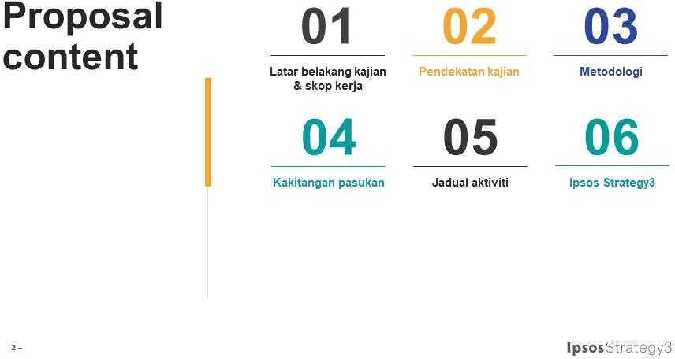

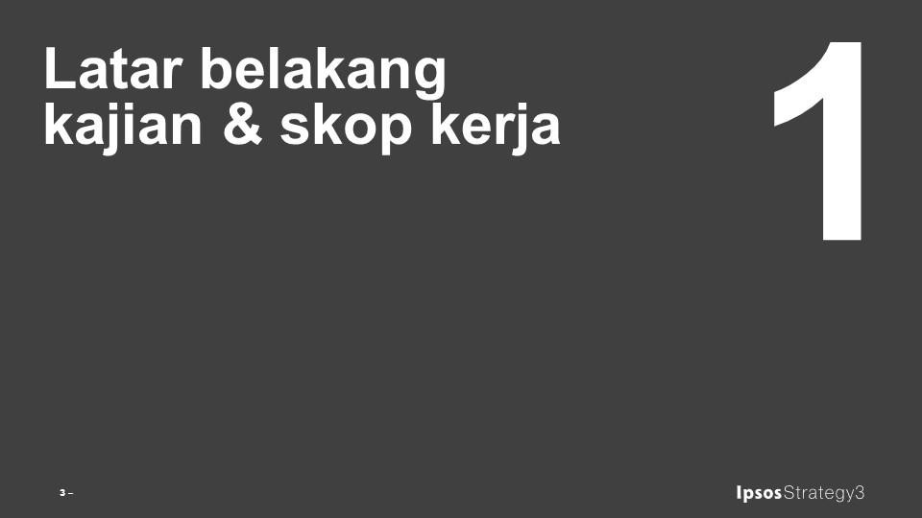

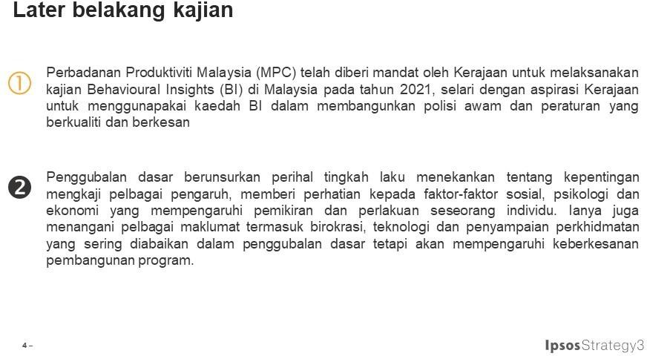

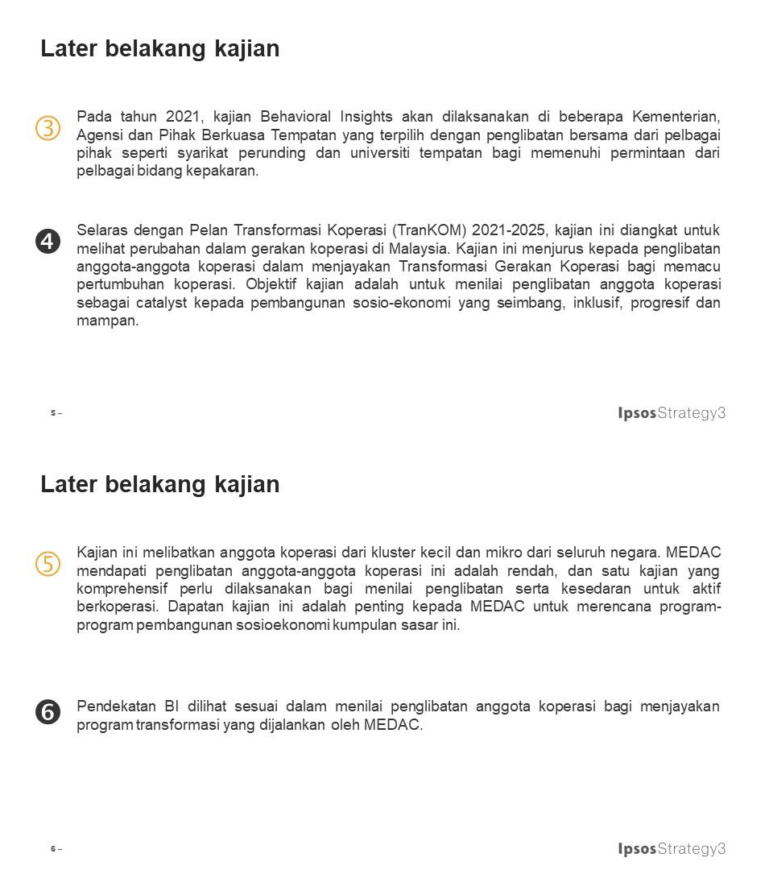

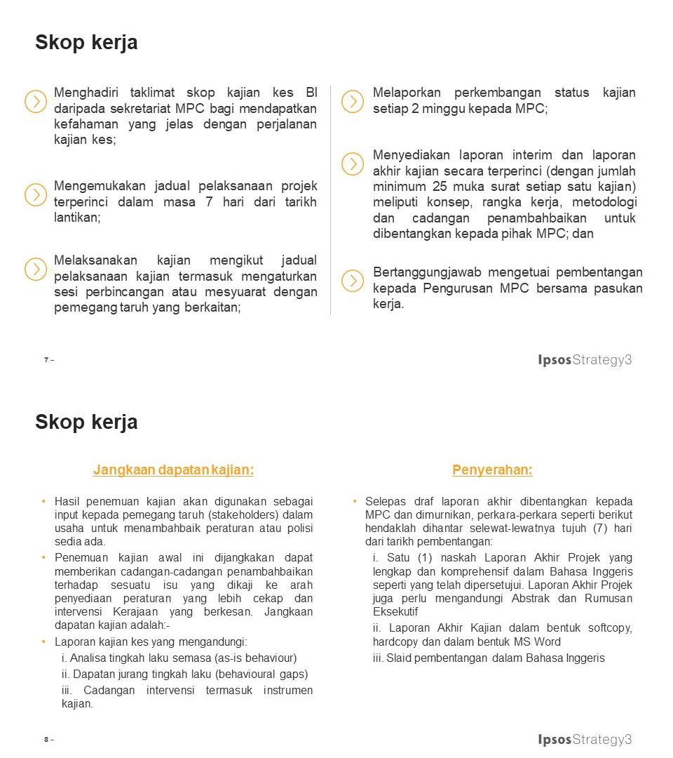

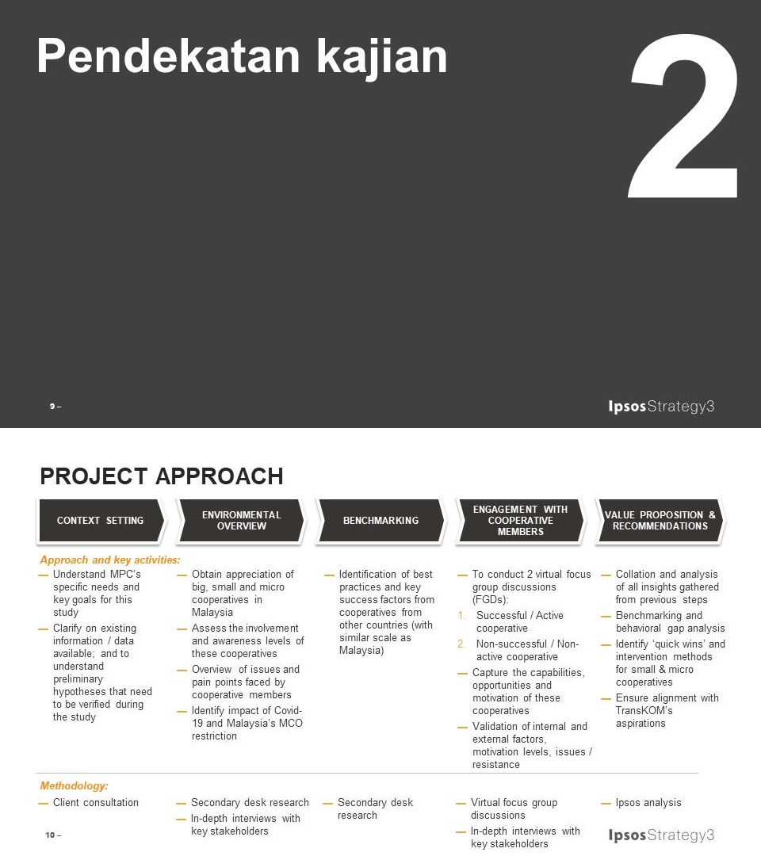

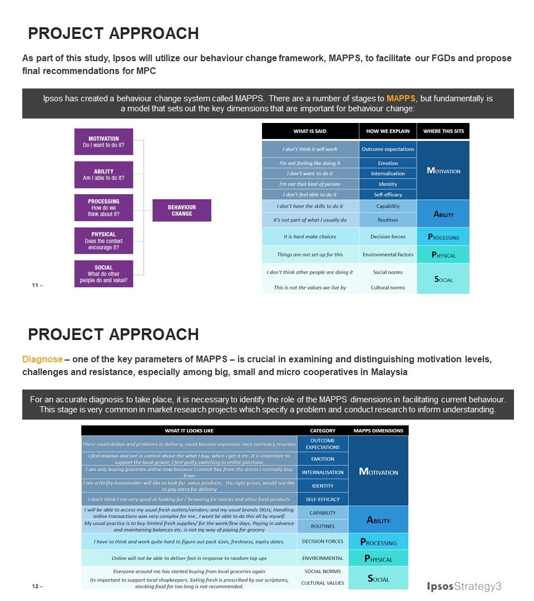

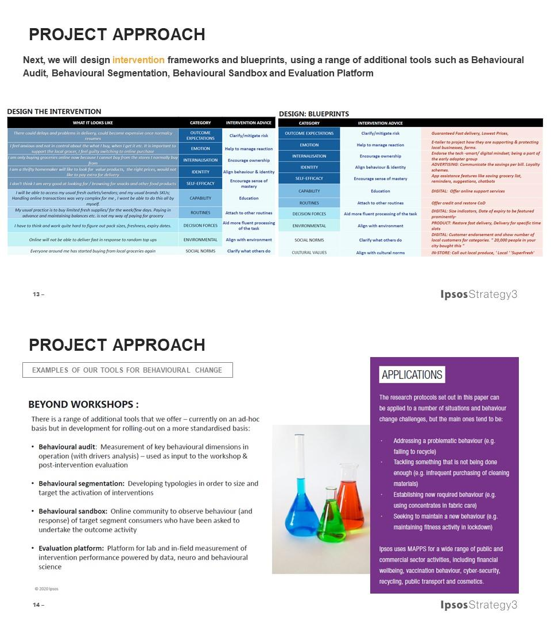

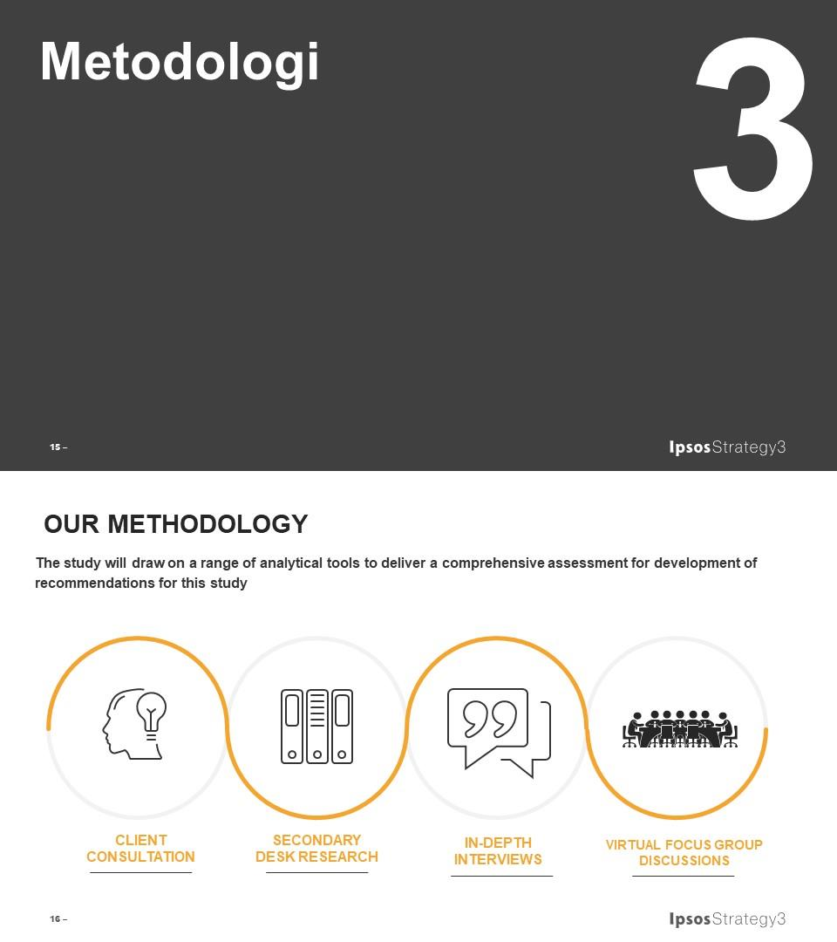

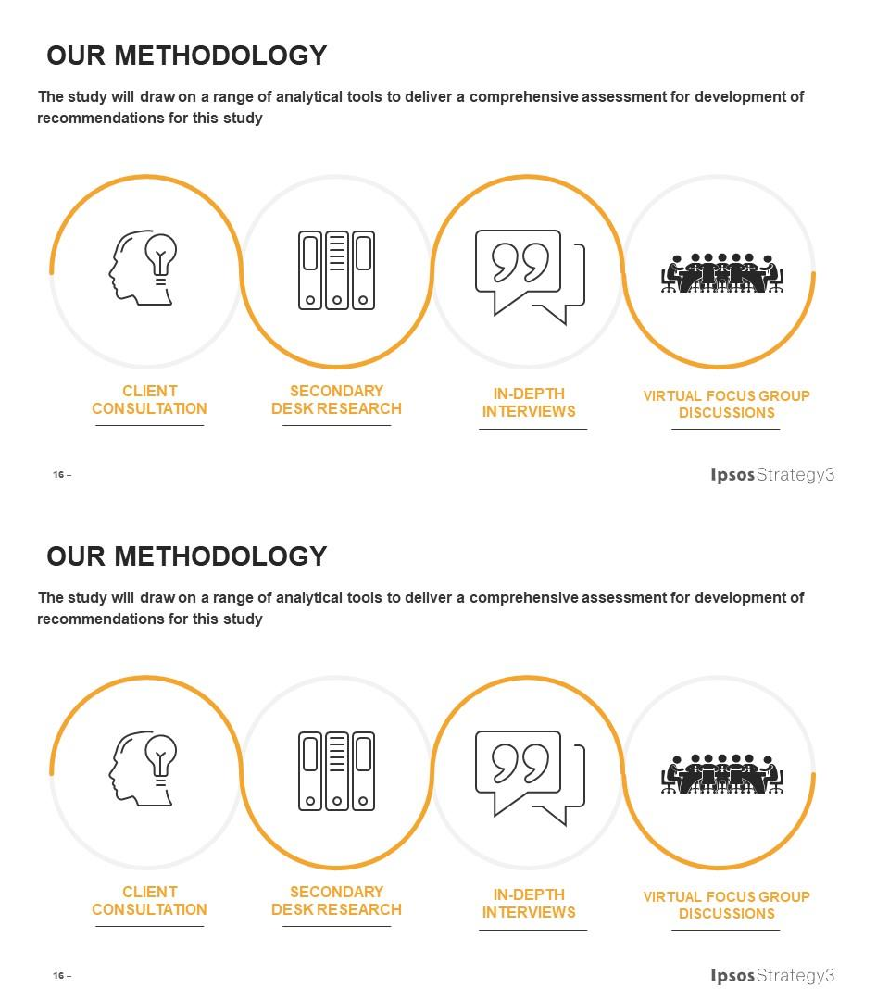

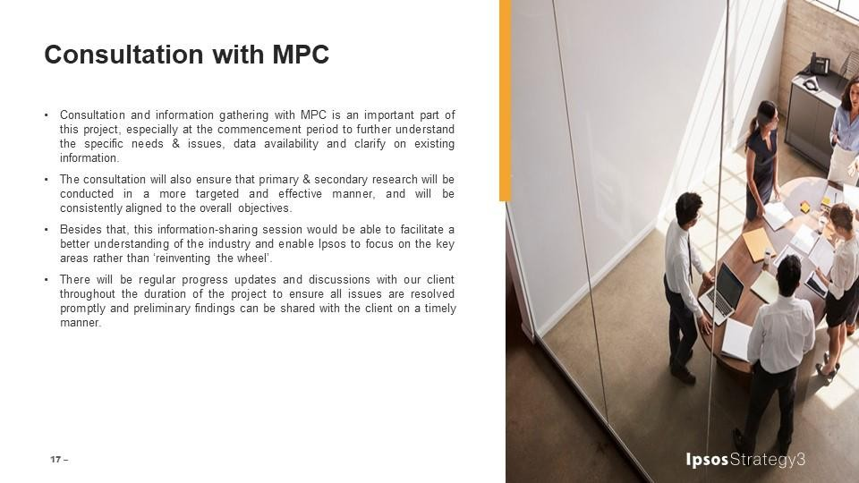


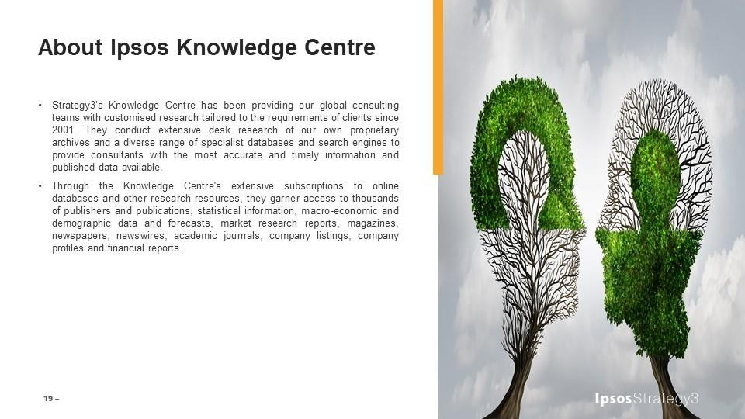
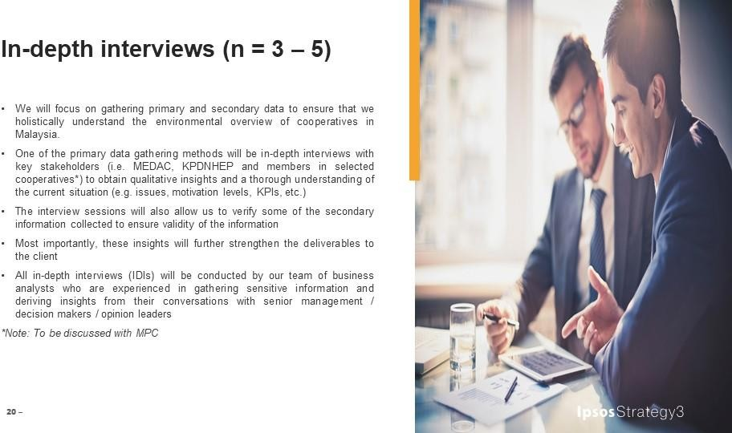

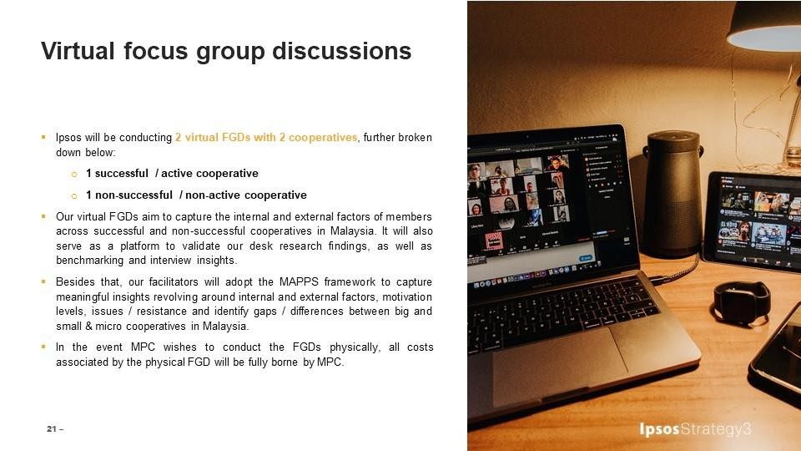

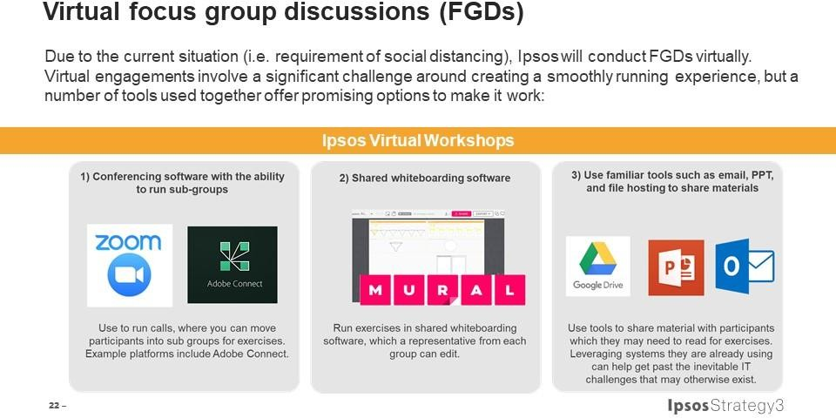


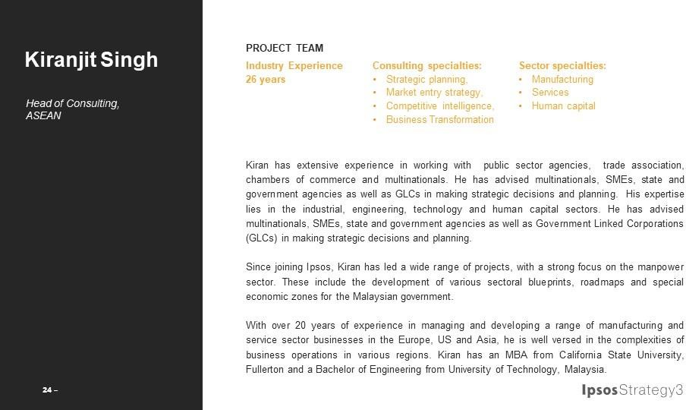

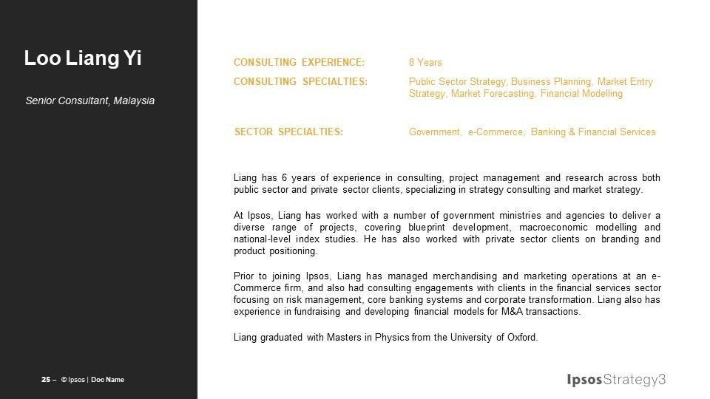
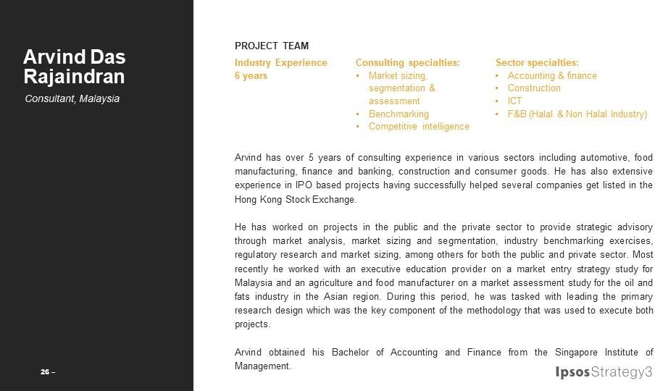

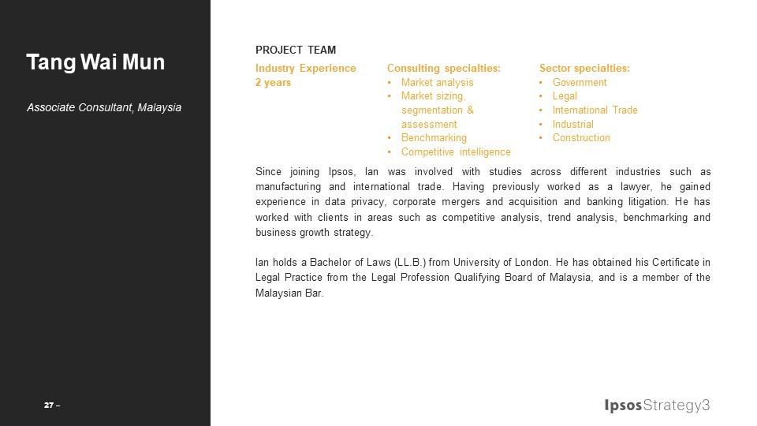
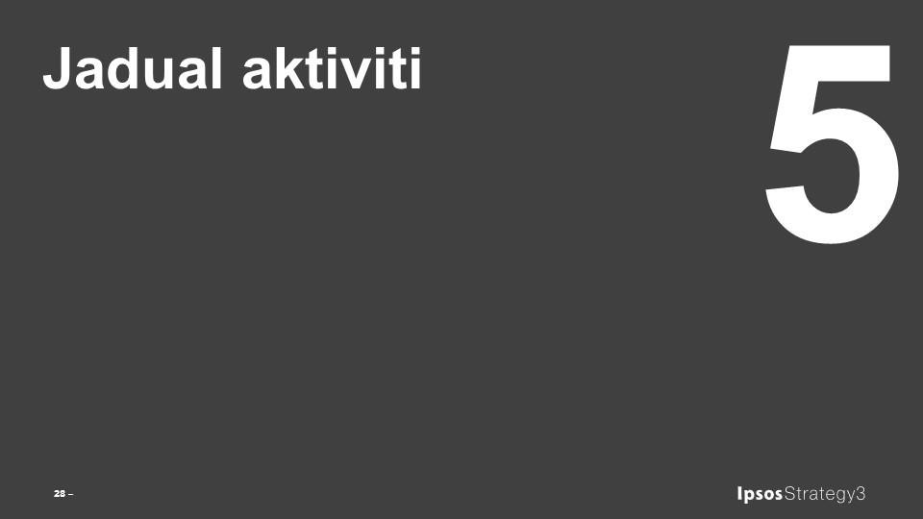

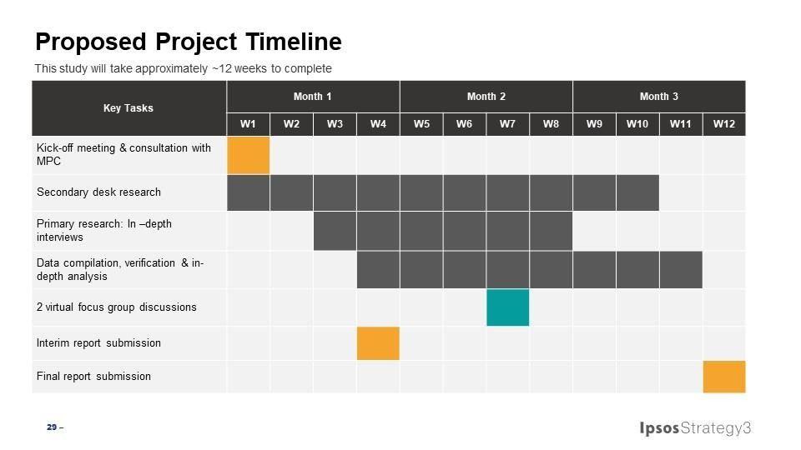
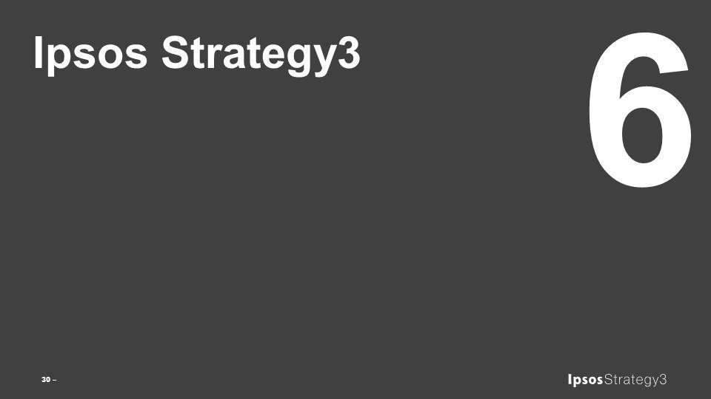

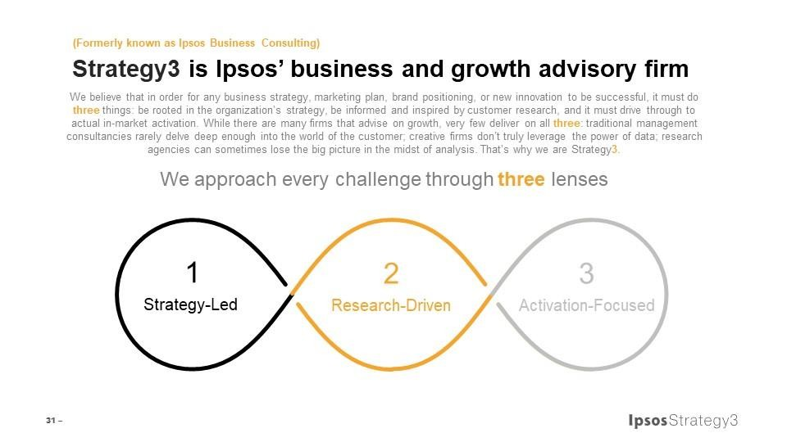





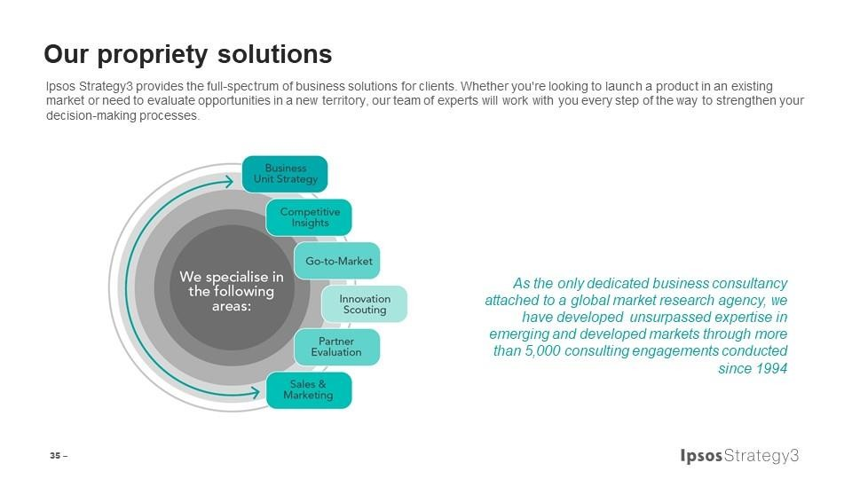

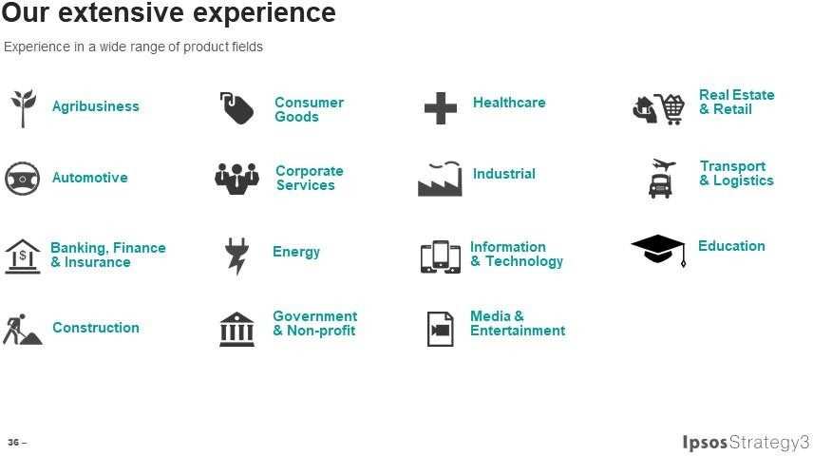




APPENDIX 3

APPENDIX 3 : LETTER OF ACCEPTANCE

Surat SST (will insert by MPC)

APPENDIX 4

APPENDIX 4 : DELIVERABLES

No. | Deliverables Stages | Due Date of Submission
1. | Interim Report | 25 April 2021
2. | Final Report | 25 June 2021

APPENDIX 5A

APPENDIX 5A : SUMMARY OF TOTAL CONSULTING COST

Bil. | Perkara | Jumlah (RM)
(1) Yuran Perunding
 | A. Kakitangan Ikhtisas | 37,260
 | B. Kakitangan Separa Ikhtisas | TIADA
JUMLAH (1)
(2) Kos Imbuhan Balik
 | i. Tiket Penerbangan Tempatan/Antarabangsa
 | ii. Lain-lain Perbelanjaan Berkaitan Dengan Perjalanan termasuk Teksi
 | iii. Tuntutan Perjalanan Kenderaan (Mileage Claims)
 | iv. Elaun Penginapan dan Sara Hidup
 | v. Kos Perhubungan
 | vi. Kos Dokumentasi Dan Penyediaan Laporan
 | vii. Kos Bagi Menjalankan Projek / Kajian Selidik
JUMLAH (2) |  | -
JUMLAH KESELURUHAN KOS PERUNDING (1)+(2) |  | 37,260
JUMLAH (termasuk 6% CBP) |  | 39,495.60

Form CSA2014-Research (Amendment 2018)

APPENDIX 5B

APPENDIX 5B : CONSULTING FEES

 |  |  |  | (1) | (2) | (3)
Bil | Nama | Status Kakitangan (Tetap/ Sementara) | Tempoh Pengalaman Bekerja (Tahun) | Gaji  Pokok (Sebulan) | Input Masa (Bulan) | Faktor Pengganda (Rujuk Lampiran A4) | Jumlah Yuran
 |  |  |  | RM | Input Masa (Bulan) | Faktor Pengganda (Rujuk Lampiran A4) | RM
A) YURAN PERUNDING BAGI KAKITANGAN IKHTISAS (INPUT MASA)
1. | Loo Liang Yi | Tetap | 7 | 7,500 | 0.4 | 2.7 | 8,100
2 | Arvind Das Rajaindran | Tetap | 6 | 6,000 | 0.7 | 2.7 | 11,340
3 | Tang Wai Mun | Tetap | 2 | 3,000 | 2.2 | 2.7 | 17,820
JUMLAH KECIL (i) |  |  |  |  |  |  | 37,260
B) YURAN PERUNDING BAGI KAKITANGAN SEPARA IKHTISAS (INPUT MASA)
JUMLAH KECIL (ii) |  |  |  |  | - | - | -
JUMLAH BESAR YURAN PERUNDING: (i) + (ii) |  |  |  |  | - | -

APPENDIX 5C

APPENDIX 5C : OUT OF POCKET EXPENSES

- NIL -

APPENDIX 6

APPENDIX 6 : SCHEDULE OF AGREED ITEMS

Item | Clause of Agreement | Description | Remarks
1. | 3.1 | Commencement date | 25 March 2021
2. | 3.1 | Contract period | 3 months
3. | 3.1 | Contract Expiry date | 25 June 2021
4. | 3.2(b) | Period for negotiation of the terms and condition for extension of the contract period | Two (2) weeks prior to Contract Expiry Date
5. | 1.1(c),  5.12(c),  6.1(a) &  8.1(a) | MPC’s Representative (MPCR) | - Sawiah Abdul Samad  - Noor Aishah Hj Hassan  - Haslizayanti Othman  - Izzul Ikhwan Ishak
6. | 6.2(b) | Period for MPC to give decision | Seven (7) days
7. | 6.4(c) | Consultant’s bank account details for purposes of payment | Name: IPSOS SDN BHD  Account No.: 359384179101  Bank Address: HSBC BANK  MALAYSIA BERHAD
8. | 14(d) | Period for Consultant to submit statement of final account for the  Services and supporting documentation to MPCR | Seven (7) days
9. | 14(e) | Period for MPCR to verify the statement of account and supporting documentation. | Fifteen (15) days
10. | 5.3(b) | Formula for calculation of Liquidated and Ascertained Damages:  LAD = % BLR x Fees  100 365  (subject to a minimum of RM100/- per day) | RM100/day
11 | 17(a) | - For MPC  - For the Consultant | - Perbadanan Produktiviti Malaysia Lorong Produktiviti, Off Jalan Sultan, 46200 Petaling Jaya, Selangor.  Tel. No.: 03-7960 0173  Fax No.: 03-7960 0211  - IPSOS SDN BHD  23rd Floor, Centrepoint North, Mid Valley City, Lingkaran Syed Putra, 59200 Kuala Lumpur;  Tel. No. : 03-2289 3000  Fax No.:03 2289 3600  Email : kiranjit.singh@ipsos.com

APPENDIX 7 APPENDIX 7 : SERVICES IMPLEMENTATION SCHEDULE

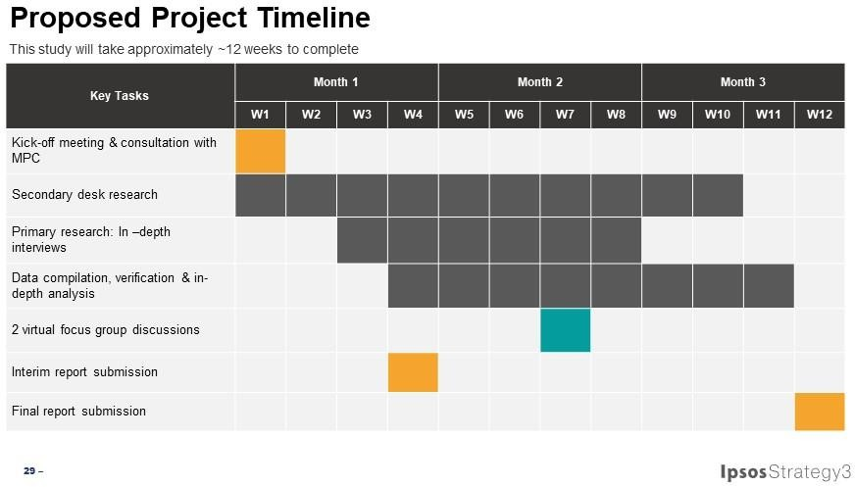

Form CSA2014-Research (Amendment 2018)

APPENDIX 8

APPENDIX 8 : CONSULTANT’S PERSONNEL

[ Please see attached proposal ]

APPENDIX 9 : CONSULTANT’S PERSONNEL TIME INPUT SCHEDULE (IF APPLICABLE)

No. | Name of Personnel  Involved in each stages | Total Time Input byeach personnel  andaccording to deliverable stages | Start Date (work commenced by  each personnel) | End Date (work ended by each  personnel)
Deliverable Stage INTERIM
1 | Loo Liang Yi | 0.2 month | Week 1 | Week 4
2 | Arvind Das Rajaindran | 0.35 month | Week 1 | Week 4
3 | Tang Wai Mun | 1.1 month | Week 1 | Week 4
Deliverable Stage FINAL REPORT
1 | Loo Liang Yi | 0.2 month | Week 5 | Week 12
2 | Arvind Das Rajaindran | 0.35 month | Week 5 | Week 12
3 | Tang Wai Mun | 1.1 month | Week 5 | Week 12

APPENDIX 10

APPENDIX 10 : CONSULTANT’S SERVICES TAX LICENSE
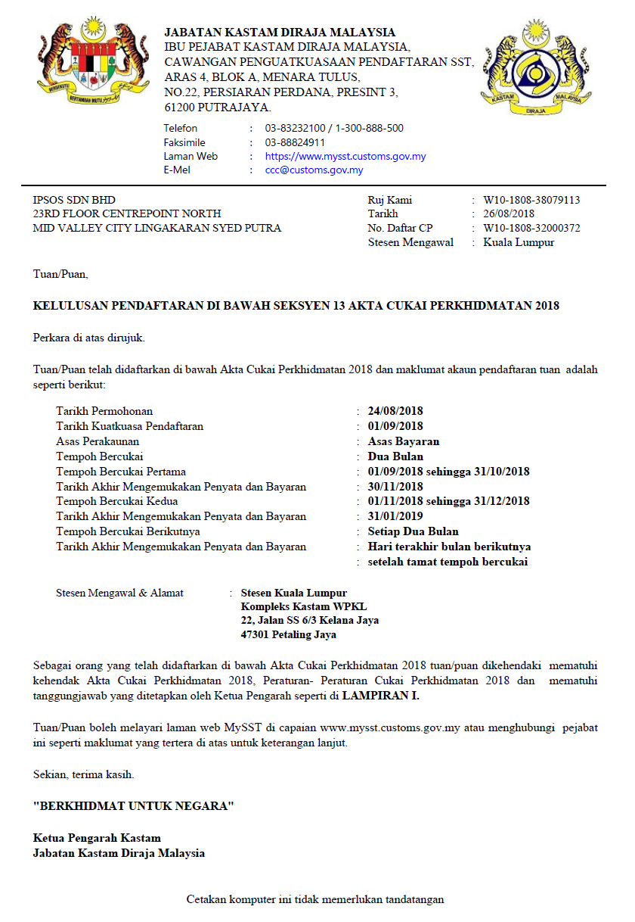

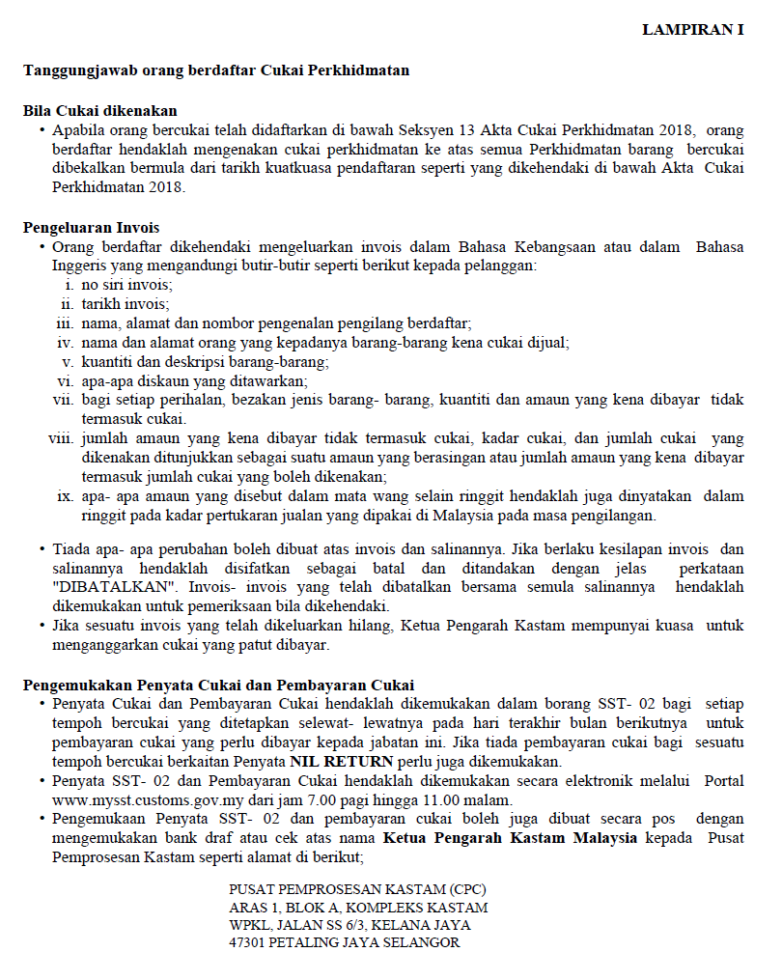

APPENDIX 11

APPENDIX 11 : SCHEDULE OF PAYMENT

PHASE | PAYMENT (RM)
PHASE 1 (40%) | 15,798.24
PHASE 2 (60%) | 23,697.36
PROJECT COST | 39,495.60

