Laporan Readiness Assessment submission sesi 1
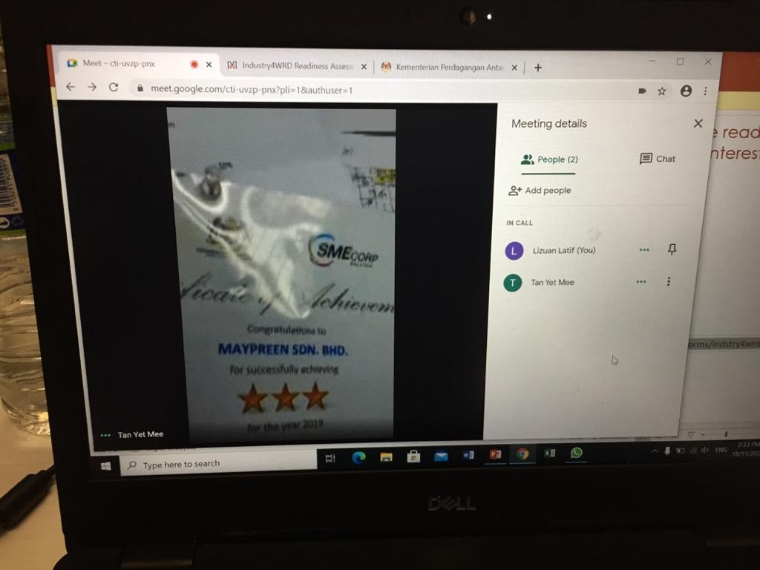
Maypreen Sdn Bhd 18 November 2020

AF Vision Sdn Bhd 23 November 2020
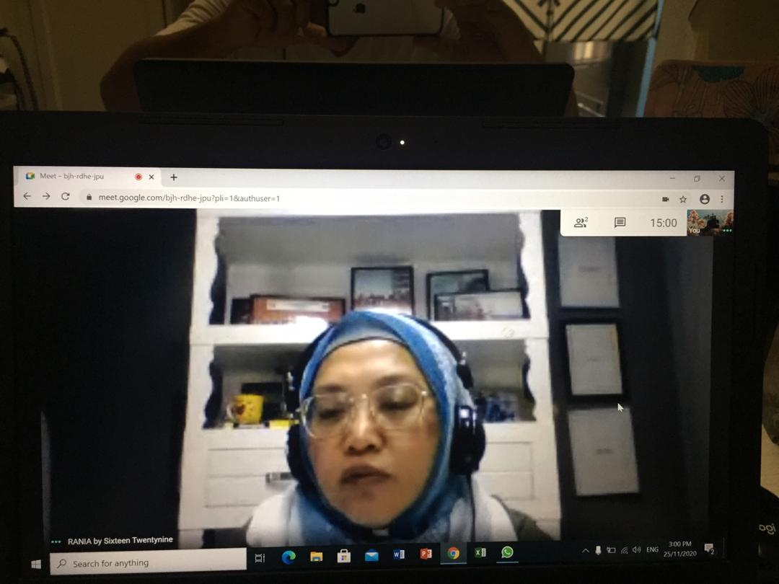
Sixteen Twentynine Sdn Bhd 25 Nov 2020
Laporan Readiness Assessment submission sesi 2
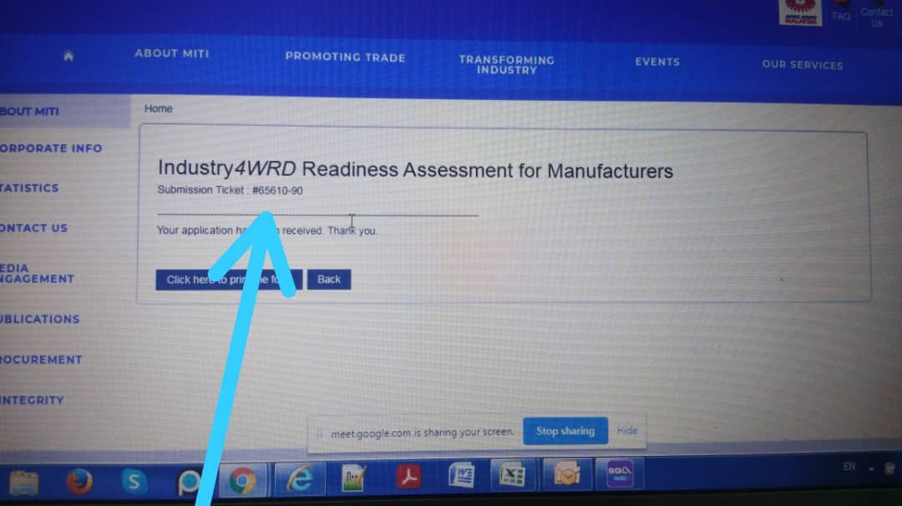
Amat Teknik Sdn Bhd 25 Nov 2020
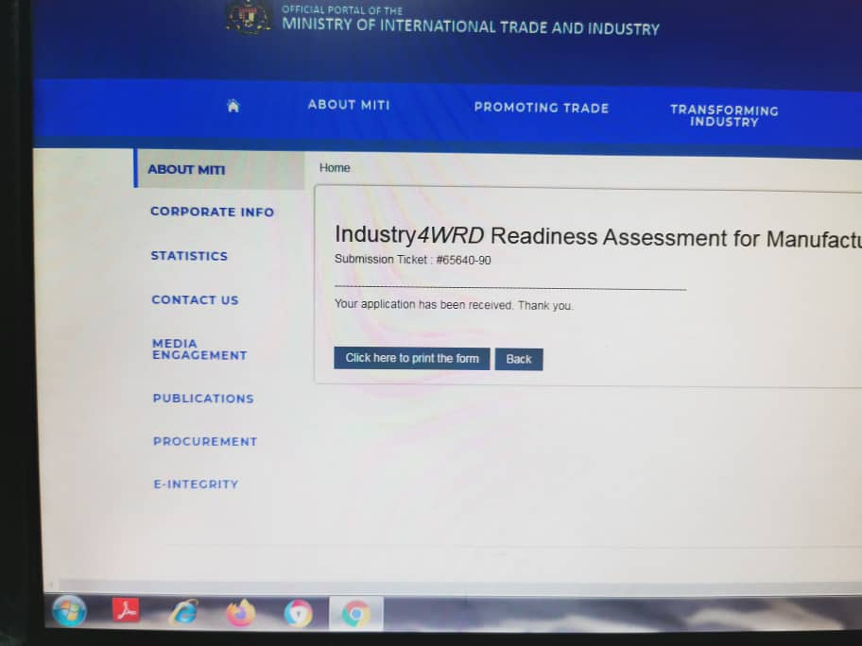
Fokus Idaman Sdn Bhd 26 Nov 2020

Grasigates Sdn Bhd 27 Nov 2020


Laporan Readiness Assessment submission sesi 3
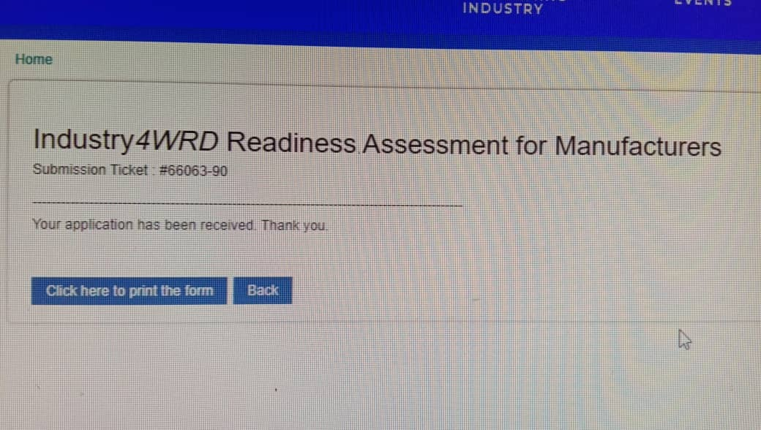

MZ Coating Sdn Bhd 10/12/2020
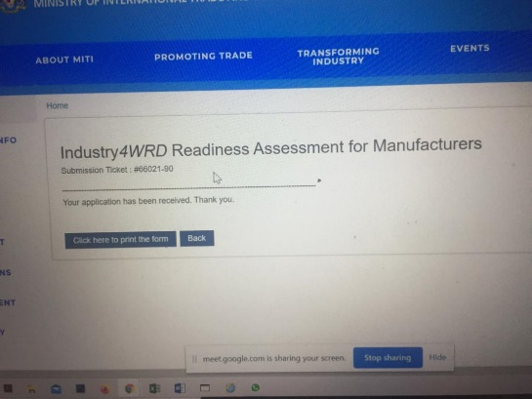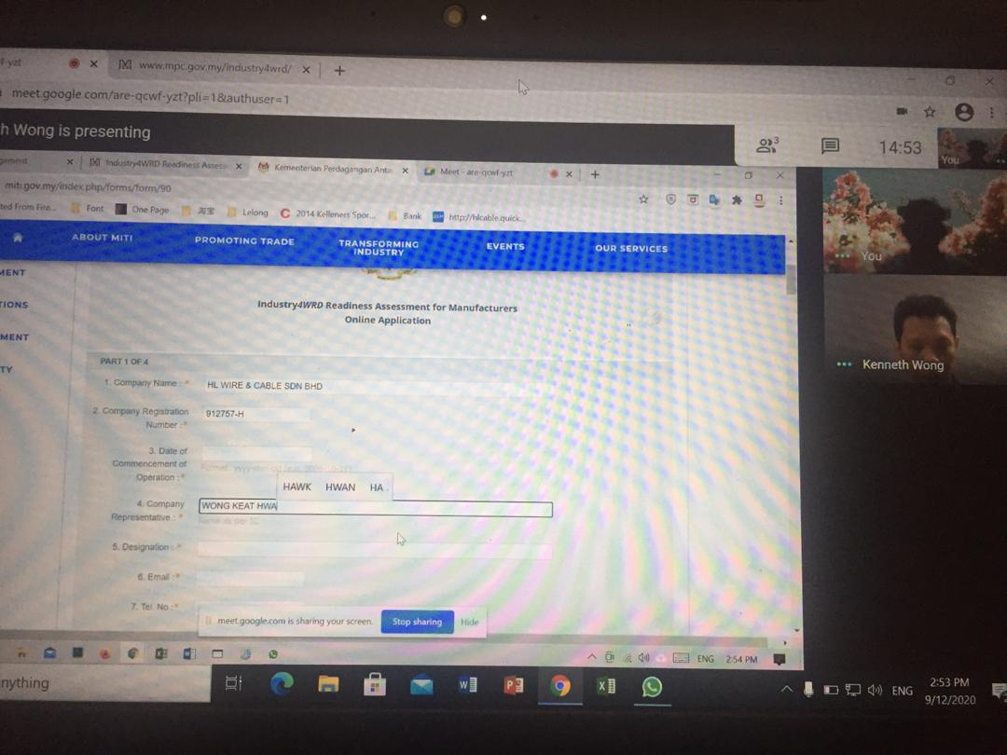
HL Wire and cable Sdn Bhd 9/12/2020

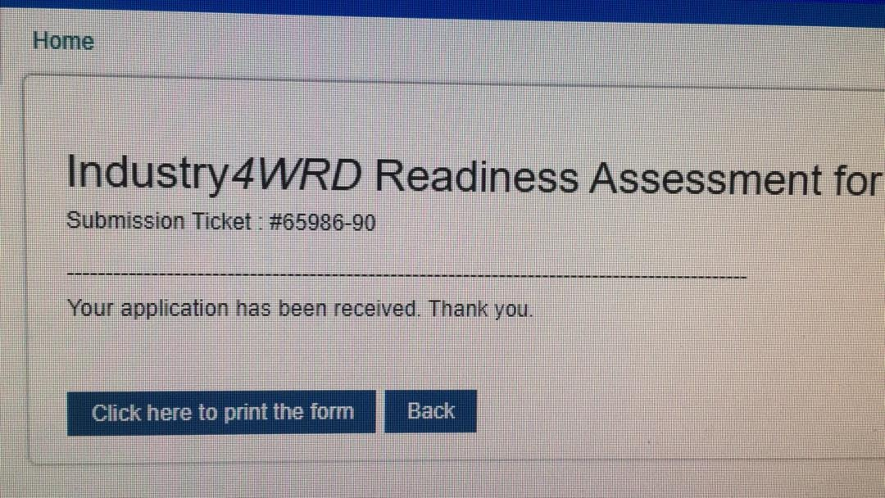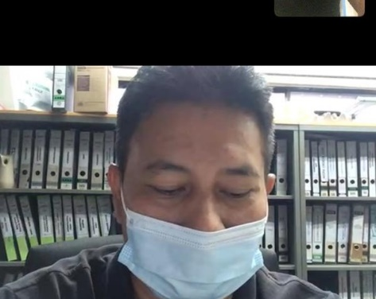
Nat Orient Sdn Bhd 8/12/2020

