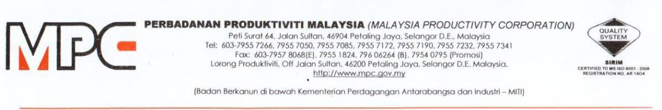

MPC (DMO) 100-12/4/6

13 July 2020

ARN Consulting
No.5, Jalan 3/66 Petaling Jaya
46000 Selangor
Tel: 017-2070155

Dear ARN Consulting,

APPOINTMENT AS AN INDUSTRY / TECHNICAL EXPERT FOR PROFESSIONAL GROWTH OF ARCHITECTURE AND ENGINEERING FRATERNITIES PROGRAM

With reference to the above subject, Professional Services Productivity Nexus (PSPN), Malaysia Productivity Corporation (MPC) would like to appoint ARN Consulting as an industry / technical expert for Professional Growth of Architecture and Engineering Fraternities program as detailed below:

PROGRAM | Professional Growth of Architecture and Engineering Fraternities program.
DURATION | 5 months (July 2020 to December 2020)
PAYMENT TERMS
  No. | Scope of Work | Payment Terms | RM
  1. | Developing models and guidelines for Professional Growth of Architecture and Engineering Fraternities | RM600 per man-day  (RM600 X 26 days) | RM15,600
  2. | Conducting virtual sharing sessions | RM200 per hour x 2 times | RM400
SCOPE OF WORK | Please refer the Terms of Reference (TOR) as per Appendix 1

2. Should you agree with the offer, please respond to MPC by signing the Acceptance Letter as per Appendix 2.

3. Any inquiries regarding this matter please contact Puan Azhani Ismail at 016 - 3549115 or e-mail to azhani@mpc.gov.my.

Thank you.

“DRIVING PRODUCTIVITY OF THE NATION”

Yours sincerely,


(NOR HALISA MOHAMAD HALIL)
for Director-General
Malaysia Productivity Corporation (MPC)



