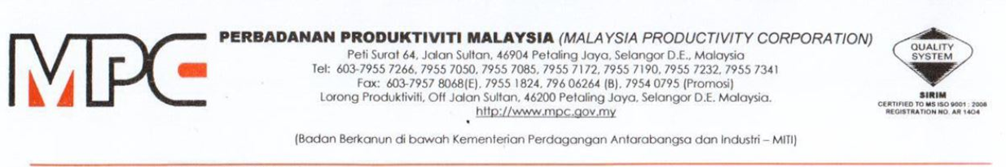
MPC (DMO) 100-12/4/6

24 November 2020

Ar. Anthony Lee Tee
Board Member
Architect Centre sdn Bhd (ACSB)

Dear Ar Anthony,

APPOINTMENT AS A SPAEKER FOR VIRTUAL SIGNING CEREMONY MEMORANDUM OF UNDERSTANDING (MOU) BETWEEN MALAYSIA PRODUCTIVITY CORPORATION (MPC) AND ARCHITECT CENTRE SDN BHD, 28TH NOVEMBER 2020, (SATURDAY), 10.30AM – 12.00PM, ZOOM WEBINAR

With reference to the above subject, Professional Services Productivity Nexus (PSPN), Malaysia Productivity Corporation (MPC) would like to appoint you as a speaker for the program as per detailed below:

PROGRAM | Virtual Signing Ceremony: Memorandum of Understanding (MoU) between Malaysia Productivity Corporation (MPC) and Architect Centre Sdn Bhd
DATE | 28/11/2020 (Saturday), 10.30am – 12.00pm
PAYMENT TERMS
  No. | Scope of Work | Payment Terms | Total
  1. | Speaker | RM300 | RM300
SCOPE OF WORK | Please refer the Terms of Reference (TOR) as per Appendix 1

2. Should you agree with the offer, please respond to MPC by signing the Acceptance Letter as per Appendix 2.

3. Any inquiries regarding this matter please contact Puan Azhani Ismail at 016 - 3549115 or email to azhani@mpc.gov.my.

Thank you.

“DRIVING PRODUCTIVITY OF THE NATION”

Yours sincerely,

(Nor Halisa Mohamad Halil)
for Director-General
Malaysia Productivity Corporation (MPC)



