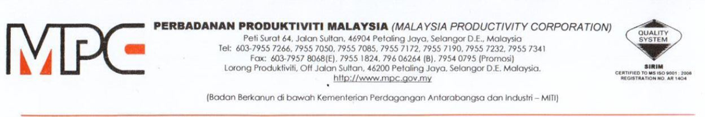
MPC (DMO) 100-12/4/6

24 November 2020

YBrs. Ar. Mustapha Kamal Zulkarnain
Blok E-1-49, Jalan PJU 1/45
Aman Suria Damansara HP: 019-318 3429
47000 Petaling Jaya, Selangor mkbz@amk.com.my

Dear Ar. Mustapha,

APPOINTMENT AS A MODERATOR FOR VIRTUAL SIGNING CEREMONY MEMORANDUM OF UNDERSTANDING (MOU) BETWEEN MALAYSIA PRODUCTIVITY CORPORATION (MPC) AND IEM TRAINING CENTRE SDN BHD, 5TH DECEMBER 2020, (SATURDAY), 10.30AM – 12.00PM, ZOOM WEBINAR

With reference to the above subject, Professional Services Productivity Nexus (PSPN), Malaysia Productivity Corporation (MPC) would like to appoint you as a moderator for the program as per detailed below:

PROGRAM | Virtual Signing Ceremony: Memorandum of Understanding (Mou) between Malaysia Productivity Corporation (MPC) and IEM Training Centre Sdn Bhd
DATE | 5/12/2020 (Saturday), 10.30am – 12.00pm
PAYMENT TERMS
  No. | Scope of Work | Payment Terms | Total
  1. | Moderator | RM250 X 2 hours | RM500
SCOPE OF WORK | Please refer the Terms of Reference (TOR) as per Appendix 1

2. Should you agree with the offer, please respond to MPC by signing the Acceptance Letter as per Appendix 2.

3. Any inquiries regarding this matter please contact Puan Azhani Ismail at 016 - 3549115 or email to azhani@mpc.gov.my.

Thank you.

“DRIVING PRODUCTIVITY OF THE NATION”

Yours sincerely,

(Nor Halisa Mohamad Halil)
for Director-General
Malaysia Productivity Corporation (MPC)



