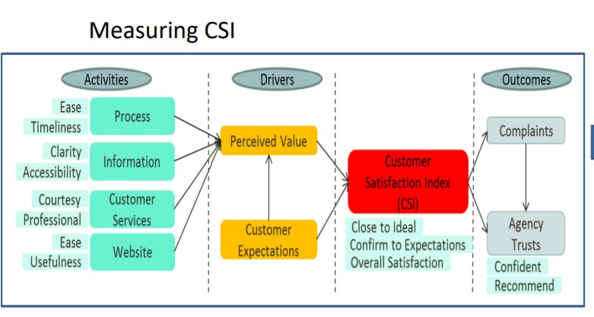PROPOSAL

CUSTOMER SATISFACTION INDEX & IMPACT STUDY -2019
1.0 Introduction & Background
Customer Satisfaction is a measure whereby organization determine how happy or satisfied their customers are with the products and services provided. A happy customer is a loyal customer. Customer satisfaction indicators and measurement provide direction as how to improve and better themselves in the provision of services. Customer satisfaction in the public sector revolves around the deliver of quality service to the public which are quantifiable and measure.

MPC - being a government agency and in line with their mission of providing high impact quality service for the betterment of life has been in the last 4 years been conducting Customer Satisfaction Survey among their customers particularly those who participated in MPC’s programs. The annual survey is aimed to understand any service gaps and to invoke initiatives that could propel MPC to provide a higher level of service excellence.

2.0 Project Background
The CSI Impact study project is a quantitative – monitoring exercise base on causal relationship between a set of predetermined framework. For consistency and tracking purposes, the Following CSI Framework will be use.

Market Insights

The calculation of the CSI – Customer Satisfaction index will be based on Partial Least Square (PLS) regression analysis which has been adopted since 2015. PLS uses structural equation modelling that allows estimation of cause-effect relationship with latent variables.

Purpose of the Proposal

The purpose of the proposal are as follows :

    - To conduct a Customer Satisfaction Index for MPC
    - To study the impact of the participation of P&I program on the firm’s Product, Service Quality, Cost , Delivery & Morale
    - To monitor and track the CSI against previous years (last 3 years)

Scope of Work
The study is targeted at MPC’s customers’ namely participants of MPC P & I programs from January – December 2019.
MPC P & I program include :
    - Capacity Development,
    - Enterprise Innovation Intervention Program (EIIP)
    - Certification Programs
    - Award Program
Participants in Nexus programs will also be interviewed.

5.0 Methodology
A multi modal approach will be undertaken – telephone interview and on-line survey will be use for the data collection. Since this is a monitoring exercise, the same questionnaire will be use for data collection.

Market Insights

  - Sample Size
For analysis and segmentation purposes, 2 target groups will be engaged for the data delivery :
    - Government Sector
    - Corporate
For each segment – data from 150 respondents will be collected
(A sample of 200 with a Confidence Interval of 90% has a Margin of Error of 6.0% A total sample of 400, at Confidence Interval of 90%, has a Margin of Error - MOE 5%)

7.0 Questionnaire
The following questionnaire will be use – for the data collection

Customer Expectation

1 | Before attending the programme: what was your expectation of the overall quality service from MPC?

Perceived Quality - Information

2 | Ease of getting information about MPC services
3 | Information about MPC services was clear and understandable

Perceived Quality - Process

4 | Services provided by MPC timely and efficient
5 | Difficulty in obtaining services from MPC

Perceived Quality – Customer Service

6 | Courtesy of MPC personnel
7 | Professionalism of MPC personnel

Perceived Quality – Website

8 | MPC Website Contents logically organised
9 | MPC Website – ease of use
10 | The usefulness of information in the website - Current / Accurate / Helpful Relevant
Market Insights

Overall Quality of service

11 | How would you rate the overall quality of MPC’s services from your most recent participation? “1” means “not very high” and “10” means “very high”
12 | CSI : Overall Satisfaction with MPC
13 | MPC ability to meet your expectations /
14 | Ideal Government Agency / Agensi Kerajaan yang Ideal  Please take a moment to imagine your ideal Government Agency. How does MPC compare with your ideal Government Agency?, “1” means “not very close to your ideal” and “10” means “very close to your ideal”

Agency Trust
15 | How confident are you that MPC will provide good or better services in the future? “1” means “not at all confident” and “10” means “very confident”
16 | Would you be willing to say positive things about MPC “1” means “not at all willing” and “10” means “very willing”

Complaint
17 | How well your complaint was handled? “1” is “not very well” and “10” is “very well”.

IMPACT

1 | Has enhanced the quality of my organisation’s /company’s products/services.
2 | Contributed to the reduction of my organisation’s/ company’s cost (production and others)
3 | Resulted in increased of my organisations’s / company’s on-time delivery of products or services (efficiency).
4 | Reduced the organisation’s / company’s accident rate
5 | Has boosted my morale in general.
6 | Increase adoption of digitalisation in my organisation
7 | Increase adoption of digitalisation at home and my daily life
8 | Increase my productivity at work
9 | Increase my productivity at home
10 | Help to inculcate/ introduce productivity culture in my organisation
11 | Help to inculcate/ introduce productivity culture at home

Market Insights

8.0 Responsibilities Our responsibility will be :
Collect data & conduct interview based on the listing provided by MPC Maintain the Quality of the data collected
Monitor and track the CSI for MPC

9.0 Deliverables
The deliverable will be powerpoint charts for all the question with a 4 page Executive Summary detailing the salient points.

Propose Schedule

Activity | Date
Submission of Proposal | 8 July 2020
Acceptance of Proposal | 15 July 2020
Questionnaire Design and Listing | 28 July
Data Collection | 3 August – 31 August
Analysis of Data | 1st - 14Sept 2020
Presentation of Report in ppt | 15 Sept 2020
- Propose Costing Project Cost :
Progress | Progress Payment | Total
Inception reports | 30% | RM 5,400.00
Preliminary reports | 30% | RM 5,400.00
Final reports | 40% | RM 7,200.00
TOTAL COST |  | RM 18,000.00

Market Insights

THE END
Proposal Submitted by : Market Insights Consultancy
No 16C SS21/62 Damansara Utama
47400 PJ. Selangor

