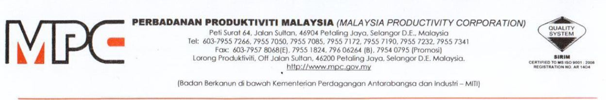
MPC (DMO) 100-12/4/6

2 November 2020

Mr Soo Hoo Yoon Hun
International Master Trainer
Lot 9561, Jalan SS 12/1d, SS12, Subang Jaya, Selangor
019-4091161

Dear Mr Soo Hoo,

APPOINTMENT AS A PANELIST FOR WEBINAR SERIES ON ADOPTION OF TECHNOLOGY SOLUTIONS AMONG PROFESSIONAL SERVICE PROVIDERS

With reference to the above subject, Professional Services Productivity Nexus (PSPN), Malaysia Productivity Corporation (MPC) would like to appoint you as a panelist for Webinar Series on Adoption of Technology Solutions among Professional Service Providers as per detailed below:

PROGRAM | WEBINAR SERIES ON ADOPTION OF TECHNOLOGY SOLUTIONS AMONG PROFESSIONAL SERVICE PROVIDERS
DURATION | 2 Months (November – December 2020)
PAYMENT TERMS
  No. | Scope of Work | Payment Terms
  1. | Panelist (1 hour per session) | RM500 / session
SCOPE OF WORK | Please refer the Terms of Reference (TOR) as per Appendix 1

2. Should you agree with the offer, please respond to MPC by signing the Acceptance Letter as per Appendix 2.

3. Any inquiries regarding this matter please contact Puan Azhani Ismail at 016 - 3549115 or email to azhani@mpc.gov.my.

Thank you.

“DRIVING PRODUCTIVITY OF THE NATION”

Yours sincerely,

(Nor Halisa Mohamad Halil)
for Director-General
Malaysia Productivity Corporation (MPC)



