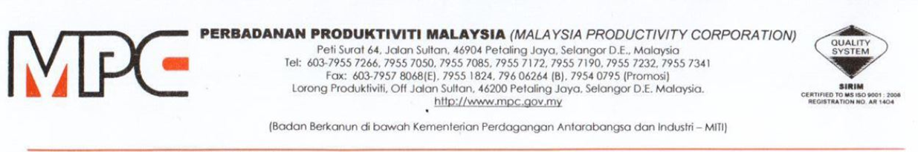
MPC (DMO) 100-12/4/6

13th October 2020

Ts. Chu Wei Yew
No. 41, Japan USE 14/1H, Subang Jaya, 47630 Selangor
HP: 012 2663020
mailto:chuwy@plytec.com.my

Dear Ts Chu,

APPOINTMENT AS A MODERATOR FOR WEBINAR SERIES ON ADOPTION OF TECHNOLOGY SOLUTIONS AMONG PROFESSIONAL SERVICE PROVIDERS

With reference to the above subject, Malaysia Productivity Corporation (MPC) would like to appoint you as a moderator for Webinar Series on Adoption of Technology Solutions among Professional Service Providers as per detailed below:

PROGRAM | WEBINAR SERIES ON ADOPTION OF TECHNOLOGY SOLUTIONS AMONG PROFESSIONAL SERVICE PROVIDERS
DURATION | 2 months (October to November 2020)
PAYMENT TERMS
  No. | Scope of Work | Payment Terms | Total
  1. | Moderator | RM250 x 5 sessions | RM1,250
SCOPE OF WORK | Please refer the Terms of Reference (TOR) as per Appendix 1

2. Should you agree with the offer, please respond to MPC by signing the Acceptance Letter as per Appendix 2.

3. Any inquiries regarding this matter please contact Puan Azhani Ismail at 016 - 3549115 or email to azhani@mpc.gov.my.

Thank you.

“DRIVING PRODUCTIVITY OF THE NATION”

Yours sincerely,

(Nor Halisa Mohamad Halil)
for Director-General
Malaysia Productivity Corporation (MPC)



