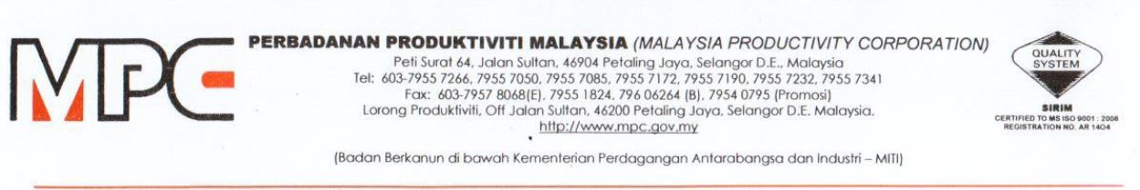

MPC (DMO) 100-12/4/6

13 October 2020

Nicole Ong
ZC-03-3A, Zest Service Apartment, Jalan Kinrara 6B
Bandar Kinrara, BK 9, 47180 Puchong, Selangor
HP: 0 12-969 3188
Email: ongbh@plytec.com.my

YBrs. Ms. Nicole,

APPOINTMENT AS A COORDINATOR FOR WEBINAR SERIES ON ADOPTION OF TECHNOLOGY SOLUTIONS AMONG PROFESSIONAL SERVICE PROVIDERS

With reference to the above subject, Professional Services Productivity Nexus (PSPN), Malaysia Productivity Corporation (MPC) would like to appoint you as a coordinator for the project as detailed below:

Program | Adoption of Technology Solutions among Professional Service Providers
Duration | October to November 2020
Payment Terms | - Coordinator (RM500 X 10 Sessions = RM5,000)
Scope of Work | Terms of Reference (TOR) as per Appendix 1

2. Should you agree with the offer, please respond to PSPN, MPC by signing the Acceptance Form as per Appendix 2.

3. Any inquiries regarding this matter, please contact Puan Azhani Ismail at 016 - 3549115 or e-mail to azhani@mpc.gov.my.

Thank you.

“DRIVING PRODUCTIVITY OF THE NATION”

Yours sincerely,

(Nor Halisa Mohamad Halil)
for Director-General

Malaysia Productivity Corporation (MPC)

