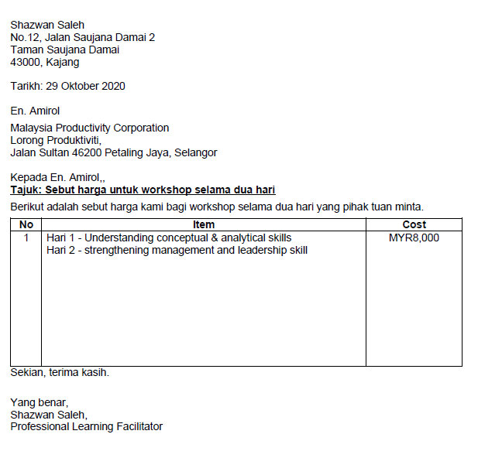
RM 6000
PERKHIDMATAN MENGENDALIKAN KURSUS CERTIFIED NEURO LINGUISTIC PROGRAMMING (NLP) PRACTITIONER
- BAHAN KURSUS (BUKU KERJA NLP, UJIAN PROFILING, BAHAN NOTA)

