EXECUTIVE SUMMARY

TITLE | : | Information Paper: Behavioural Insights Project in Improving Covid-19 Standard Operating Procedures (SOP) Compliance
OBJECTIVES | : | - To promote and use Behavioural Insights (BI) methodology to identify ways to improve the SOP compliance  - To do relative comparison with other sectors and identify best practices to improve SOP Compliance  - To provide recommendations to the related authorities in improving of Covid-19 SOP Compliance.
EXPECTED OUTCOMES | : | Project reports with baseline ('as is') issues and provide with recommendations to improve the compliance of covid-19 SOP at jetty to Langkawi
DURATION | : | January – March 2021
TOTAL COST | : | RM 65,000.00
BUDGET | : | RMK12 – Behavioural Insights (2021)  Budget to be obtained from approved BOM Paper ‘Pelaksanaan Kajian Kes Dan Projek Inisiatif Behavioural Insights (BI) Bagi Tahun 2021 – Fasa 1’ (BOM No. 9/2021; Dated 08/01/2021). Total approved budget is RM 524,000.00.
RECOMMENDED BY | : | Productivity and Competitiveness Development (PCD) / National Competitiveness (NC)
COMMENT/ SIGNATURE BY PCT | :

MALAYSIA PRODUCTIVITY CORPORATION (MPC)

PROPOSAL FOR BOARD OF MANAGEMENT

TITLE: BEHAVIOURAL INSIGHTS PROJECT IN IMPROVING COVID-19 STANDARD OPERATING PROCEDURES (SOP) COMPLIANCE

1.0 Purpose

The purpose of this paper is to inform the Board of Management (BOM) to do Behavioural Insights Project in Improving Covid-19 Standard Operating Procedures (SOP) Compliance using Behavioural Insights development budget of RM65,000 utilising approved budget under BOM No. 9/2021 dated 8 January 2021.

2.0 Background

2.1 MPC has been given an opportunity by the Government to undertake BI programs and initiatives for Malaysia, as the Government is keen to embed BI in designing public policy towards a better quality and effective regulation.

2.2 Behavioural insights (BI) provides policymakers with a new set of tools for designing and implementing effective public policies. Behavioural Insights is an approach to policy making that builds on lessons derived from the behavioural and social sciences, including decision making, psychology, cognitive science, neuroscience, organisational and group behaviour. Through BI application, policymakers develop policies based on actual behaviour and not assumed behaviour.

2.3 An increasing number of public bodies around the globe have recognised the value of applying BI to public policy. As BI and evidence-based methodologies gain popularity with policymakers, the scope of their use is also expanding. While most applications of BI to date have focused on improving individual choices, new frontiers of applying BI include both complex individual behaviour problems and organisational behavioural change.

2.4 The Health Ministry has issued guidelines and standard operating procedures (SOPs) to be followed by tourism and hospitality sector operators during covid-19 pandemic. The numerous people in the crowded places like tourism spot, poses the risk of Covid-19 spreading among the victims and personnel on duty. Therefore, preventive measures, including social distancing, washing hands with water and soap must be upheld at all time.

3.0 Objectives

Objectives of this projects is as follows:

i. To promote and use Behavioural Insights (BI) methodology to identify ways to improve the SOP compliance.
ii. To do relative comparison with other sectors and identify best practices to improve SOP Compliance.
iii. To provide recommendations to related authorities in improving Covid- 19 SOP Compliance.

4.0 Scope of the project

The scope of the project will cover 3 locations of jetty which related to travelling to and from Langkawi.

i. Jetty Kuala Perlis

ii. Jetty Kuala Kedah

iii. Jetty Kuah Langkawi

5.0 Outputs

The expected outputs of the project will comprise of as follows:

- Reports containing materials such as presentations, work plan and best practices comparison and other relevant input.
- Recommendations for the improvement on compliances of Standard Operating Procedures (SOP) for preventive Covid19.

6.0 Duration

The estimated timeline of this project is as follows:

Activities | Jan’ 2021 |  |  | Feb |  |  |  | Mar
Activities | W2 | W3 | W4 | W1 | W2 | W3 | W4 | W1 | W2 | W3 | W4

Proposal with detail timeline

Engagement with relevant agencies/authorities (e.g. State government, LAs, terminal operator, ferry operator, tourism player etc)

Benchmarking report

Validation with related agencies/authorities

Submission of draft final report

Submission of final report

7.0 Estimated Budget

No. | Item | Estimated Cost | Total
1. | Subject Matter Expert (SME) appointment to conduct:  - Baseline study (understanding issue)  - Validate with agencies  - Best Practice Comparison  - Recommendations, draft & final report | 10 man-days x  RM2,000 | RM 20,000
2. | Workshop's Facilitators | 5 man-days x RM2,000 x 2 facilitators | RM 20,000
3. | Workshops to validate data & develop recommendations  - Kedah State Authorities (2 series)  - Perlis State Authorities (2 series) | RM 2,500 x 4 series | RM 10,000
4. | Develop BI Instrument for Project at 3 locations | RM5,000 X 3 locations | RM 15,000
 | Total |  | RM 65,000

8.0 Approval

The approval of the Board of Management (BOM) is sought to conduct Behavioural Insights Project in Improving Covid-19 Standard Operating Procedures (SOP) Compliance using Behavioural Insights development budget of RM65,000 utilising approved budget under BOM No. 9/2021 dated 8 January 2021.

Prepared by: | Reviewed by: | Approved by:
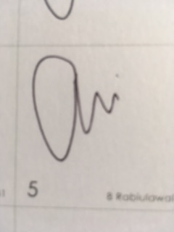 | 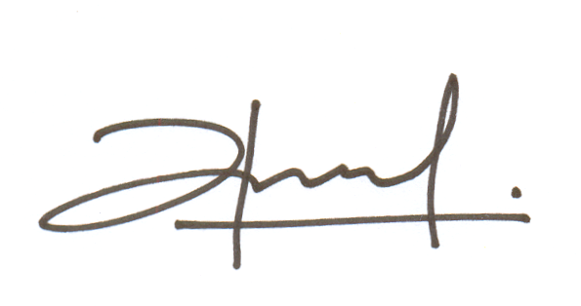 | 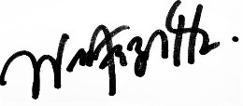
Ahmad Harris  Abdullah | Mohamad Azrol Mohamad Dali | Wan Fazlin Nadia Wan Osman
Manager, PCD | Deputy Director, PCD | Director, PCD
14 January 2021 | 14 January 2021 | 14 January 2021

