EXECUTIVE SUMMARY

TITLE | : | #MyMUDAH Programme: An Effort to Reduce Unnecessary Regulatory Burdens on Business
OBJECTIVES | : | To reduce the burden of unnecessary government regulations that impeding growth to business through:  - Analysing business concerns received from UPC; and  - Propose recommendations to the policy makers and regulators to temporarily or permanently abolished, modified, waived or exempted the unnecessary regulations that are burdensome to business.
EXPECTED OUTCOME | : | - Potential regulatory compliance cost savings from the implemented recommendations; and  - Modernise business regulations to support economic recovery and job creations.
DURATION | : | August – December 2020
TOTAL COST | : | RM335,000.00
BUDGET | : | RMK 11 – MBR/PKP (2020)
RECOMMENDED BY | : | Productivity and Competitiveness Division (PCD)
COMMENT/ SIGNATURE BY PCT | :

MALAYSIA PRODUCTIVITY CORPORATION (MPC)
PROPOSAL FOR BOARD OF MANAGEMENT:

#MyMUDAH Programme: An Effort to Reduce Unnecessary Regulatory Burdens on Business

- Purpose
The purpose of this paper is to seek for approval from Board of Management (BOM) to implement #MyMudah Programme: An Effort to Reduce Unnecessary Regulatory Burdens on Business with the estimated budget of RM335,000.00.

- Background
The Economic Action Council (EAC) meeting chaired by YAB Tan Sri Muhyiddin Yassin, Prime Minister on 20 July 2020 has agreed on “MalaysiaMudah” (#MyMudah) initiative to assist industries and businesses gain faster recovery post Movement Control Order (MCO) through reducing unnecessary regulatory burden.

EAC and MPC are tasked to intervene and to act as a solutions provider to businesses which were burdened by unnecessary regulations. The meeting also agreed that ministries and state governments need to set clear targets in an effort to reduce regulatory compliance costs.

Regulations are requirements imposed by governments that influence the decisions and conduct of businesses. Good regulation minimises compliance costs and distortions to investment (efficiency), while still achieving its objectives (effectiveness) and delivering benefits which exceed the costs it imposes (appropriateness).

- Objective
To reduce the burden of unnecessary government regulations that impeding growth to business through:
- Analysing business concerns received from UPC; and
- Propose recommendations to the policy makers and regulators to temporarily or permanently abolished, modified, waived or exempted the unnecessary regulations that are burdensome to business.

- Outputs
The expected outputs of the project will comprise of as follows:
- Reports on recommendations to reduce regulatory burden to the policy makers and regulators;
- Media release; and
- Webinar series.

- Expected Outcome
The expected outcome from this project are:
- Potential regulatory compliance cost savings from the implemented recommendations; and
- Modernise business regulations to support economic recovery and job creations.

- List of projects (Annex 1)
Under the MyMUDAH programme, the estimated number of regulatory reform projects will be addressed in 5 months are 40 projects. As of 4th week of August 2020, 30 business concerns have been registered through Unified Public Consultation (UPC) portal. The list of business concerns as per Annex 1.

- Team Members
This project will involve representatives from National Competitiveness Section and Productivity Growth Section. The main project team are as follows:

Project Champion : Zahid Ismail
Project Director : Wan Fazlin Nadia Wan Osman
Project Manager : Khidzir Ahmad
Project Coordinator : Hafizoh Md Aris
Vimala R Muniandy
Mohd Aizuddin Noor Azman
Mohd Zulkifly Rawawi

- Implementation Mechanism
The implementation mechanism for MyMudah programme as follows:

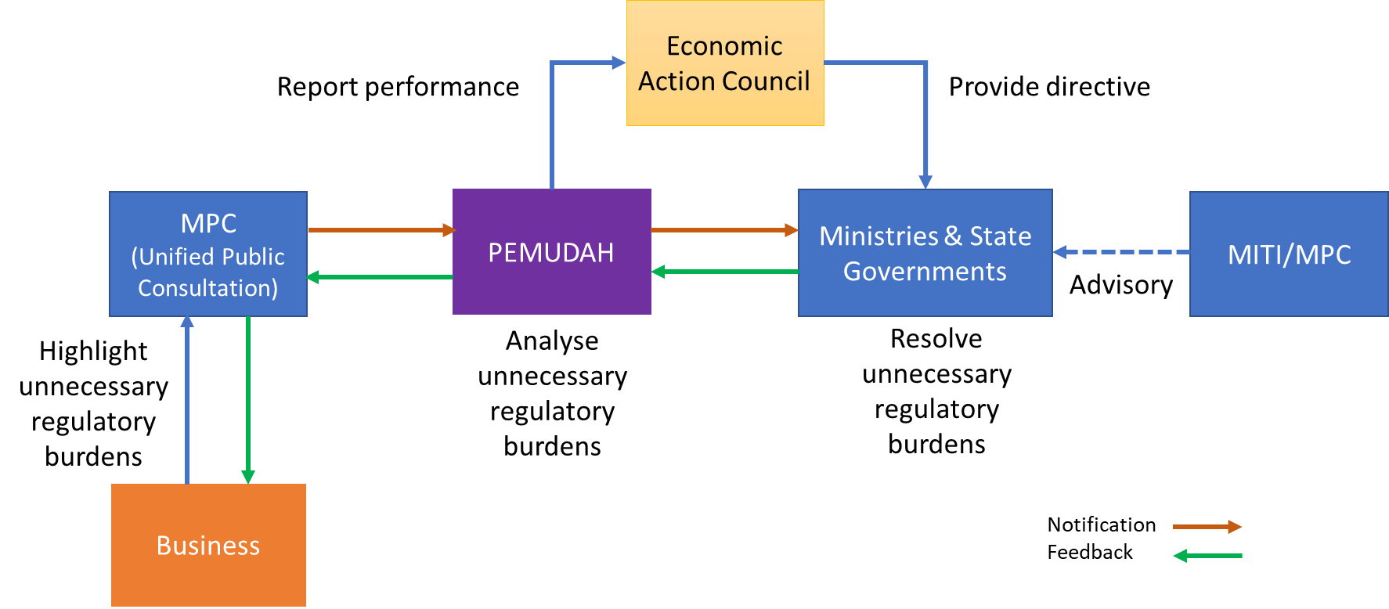

The process flow for #MyMudah as per Annex 2.

- Estimated Cost
The estimated cost for the project as follows:

ITEMS | No. of Unit/ Pax/ Pages | Cost Per Unit (RM) | No. of Hrs/ Days/ Months/ Sessions | Cost (RM)
Panel of Experts (Technical Expert/ Advisor/ Facilitator/ Moderator) | 10 experts | 200.00 | 120 hours | 240,000.00
Secretariat | 1 | 3,000.00 | 5 months | 15,000.00
Report Writer/ Document Reviewer/ Editorial/ Proofread | 200 pages | 100.00 | - | 20,000.00
Publications (Reports/ Articles/ Media release) | 30 | 2,000.00 | - | 60,000.00
TOTAL |  |  |  | 335,000.00

- Approval from BOM
The approval from the Board of Management (BOM) is sought on the budget of RM335,000.00 to implement the proposed programme.

Prepared by | : | Khidzir Ahmad  Manager, Productivity and Competitiveness Division (PCD)
Reviewed by | : | Wan Fazlin Nadia Wan Osman  Director, Productivity and Competitiveness Division (PCD)
Date | : | 2 September 2020

