

PAPER FOR APPROVAL
MPC BOARD OF MANAGEMENT (BOM)

ENCOURAGE THE ADOPTION
OF TECHNOLOGY SOLUTIONS
BY PROFESSIONAL SERVICES PROVIDERS
SEPTEMBER – DECEMBER 2020

PREPARED BY:

NOR HALISA MOHAMAD HALIL
PROGRAM MANAGER
PRODUCTIVITY NEXUS PROFESSIONAL SERVICES (PSPN)
PRODUCTIVITY GROWTH DEPARTMENT (PGD)
MALAYSIA PRODUCTIVITY CORPORATION (MPC)

HP: 013-351 7073
email: halisa@mpc.gov.my

EXECUTIVE SUMMARY
TITLE | : | Encourage the Adoption of Technology Solutions by Professional Services Providers
DURATION | : | September – December 2020
OBJECTIVES | : | - To encourage adoption of technology solutions among professional service providers;  - To create and enhance awareness about technology solutions to the professional services providers;  - To promote conceptual framework for professional services technology solutions adoption;  - To provide technology solutions industry experts through mentoring and coaching sessions to the professional services providers.
EXPECTED OUTPUT / OUTCOME | : | - A compilation matrix of solution providers according to six (6) PSPN fraternities;  - A series of webinars for awareness, understanding guidelines as well as for coaching and mentoring by industry experts;  - Terms of reference (TOR) for industry experts and professional service providers;  - Industry experts’ reports according to respective professional services fraternities;  - Real-time recommendations based on fraternities;  - Database repository retrieved from the series of webinars.
ESTIMATED COST | : | RM138,800
BUDGET | : | SPN-PSPN
COMMENT / SIGNATURE BY HEAD ACCOUNTANT | :
COMMENT / SIGNATURE BY PCT | :
REQUEST FOR APPROVAL
MPC BOARD OF MANAGEMENT (BOM)

ENCOURAGE THE ADOPTION OF TECHNOLOGY SOLUTIONS
BY PROFESSIONAL SERVICES PROVIDERS
SEPTEMBER – DECEMBER 2020

1.0 PURPOSE

1.1 The purpose of this paper is to seek for the approval of MPC’s Board of Management (BOM) to utilise the SPN - Professional Services Productivity Nexus (SPN-PSPN) budget in the quest to encourage adoption of technology solutions by professional services providers.

- BACKGROUND

  - Malaysian professional services providers are mostly small and fragmented. Most of them show low adoption of ICT and lack of technology knowledge especially amongst smaller firms and sole practitioners. They work within their own ecosystem and their companies and business have their own strategies. According to Malaysia Digital SME Study 2018, professional services in Malaysia has the lowest IT expenditure across services sector which accounts only RM37million compared to other subsector and not more than 30% establishments leverage on higher-value technology-enabled applications to increase efficiency. There is also low rates of adoption of advanced technologies such as cloud and IoT due to low IT expenditure and lack of digital adoption capabilities amongst industry players. Among the key factors behind the aversion towards technology adoption identified by the Ernst & Young’s National eCommerce Strategic Roadmap 2.0 that businesses are:
- Uncertain of how digitization can improve their business operations;
- Unsure of how new technologies will impact their overall business strategy; and
- Not aware of potential financing options available.
Despite the challenges and barriers inhibiting the use and adoption of digital technology by professional services providers, there is no doubt that new wave of innovation will drive the higher-level usage of digital technology with the Internet of Things. It is imperative for professional services providers irrespective of size must be ready and leverage on the deployment of digital technologies and tools in order to adopt the relevant technology solutions to capture the returns of fast-growing business landscape. In the IMD’s World Digital Competitiveness Ranking 2019, Malaysia was ranked 26th (2018:27th). Although the country climbed one spot, we must act fast in adapting to a fast-changing digital world to seize the opportunities that open up from this disruption.

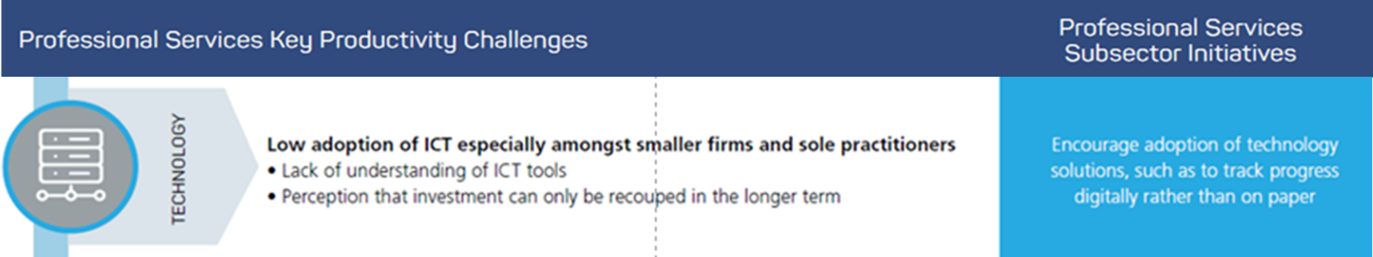

2.3 In the Malaysia Productivity Blueprint (MPB), it was stipulated under Thrust 2 of Professional Services Productivity Nexus (PSPN) to aim for encouraging adoption of technology solutions, such as to track progress digitally rather than on paper. In view of this, there is a need for a suitable model for professional services providers to increase their capacities, to sustain and grow the businesses therefore, to encourage adoption of technology solutions.

3.0. OBJECTIVES

3.1 To encourage adoption of technology solutions among professional service providers;
3.2 To create and enhance awareness about technology solutions to the professional services providers;
3.3 To promote conceptual framework for professional services technology solutions adoption;3.4 To provide technology solutions industry experts through mentoring and coaching sessions to the professional services providers.

- PROPOSED SCOPE OF TECHNOLOGY SOLUTIONS ADOPTIONS

4.1 The conceptual framework covers three (3) work streams to promote adoption of technology solutions by professional services as per the following details:

- Create and Enhance Awareness
  - Awareness to industry on the latest technology solutions in the market
  - Identify current technology adoption trends in the sector;
  - Expose, encourage and nurture spirit among professional services firms to adopt technology solutions.

- Provide Guidance
- State mission and objectives;
- Design checklists for adopting technology solutions;
- Online workshops and webinars to be deployed to provide guidance by best practices sharing;
- Established companies will be identified to provide mentoring and practical advice.

- Monitoring & Evaluation
  - Understand the adoption progress and recognise potential obstacles to ensure sustainable adoption;
  - Monitor number of processes performed on new software and capture how many savings and encourage companies to track company performance, to ensure collected data are to be interpreted into the right context and organise them to complement companies’ intelligence performance;
  - Gather successful adopters’ database.
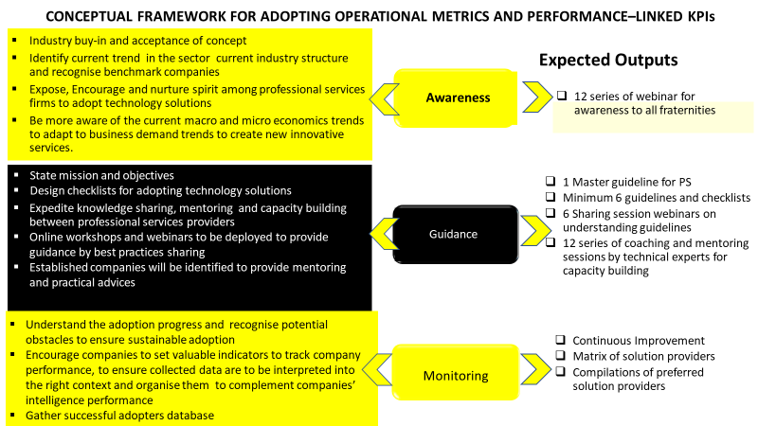

- OUTPUTS

  - The expected outputs include:

- A compilation matrix of solution providers according to different fraternities;
- A series of webinars for awareness, understanding guidelines as well as for coaching and mentoring by industry experts;
- Terms of reference (TOR) for industry experts and professional service providers;
- Industry experts’ reports according to respective professional services fraternities;
- Real-time recommendations based on fraternities; and
- Database repository retrieved from the series of webinars.

- PROPOSED IMPLEMENTATION TIMELINE AND ESTIMATED COST
  - The proposed implementation timeline and estimated cost is as follows:
No. | Activity | Details | Cost (RM)
1. | - Poster  - Promotion blasting to professional services providers covering six (6) fraternities (Accountancy, Advertising, Architectural, Engineering, Legal, and Management Consultancy) | RM200  RM4,800 | 5,000
2. | Create and Enhance Awareness  - Coordinator (for 10 webinars, 12 coaching and 6 sharing sessions)  - Webinar moderators  - Panelists (1 hour per Session)  - Webinar platforms | RM500 x 28 sessions  RM300 X 28 sessions  RM500 X 10 sessions  RM100 X 28 sessions | 14,000  8,400  5,000  2,800
3. | Provide Guidance  - Technical experts for developing checklists  - Virtual sharing sessions on technology adoption checklists  - Virtual coaching and mentoring sessions | RM10,000 X 6 pax  RM200 X 6 sessions  RM200 X 12 sessions | 60,000  1,200  2,400
4. | Monitoring & Evaluation  - Consolidation of Reports and Compilations of Matrix of Solution providers for 6 fraternities, design and typesetting  - Publication of the Compilations of preferred solution providers | RM20,000  RM20,000 | 40,000
Total |  |  | 138,800

- APPROVAL OF BOM
BIM industry knowledge group (IKG)
Output KPI
- Number of collaborative connection established
- The possibility of greater adoption of integrated BIM Level 2 in Malaysia
Outcome KPI
6.1 The approval of BOM is sought to approve the budget of RM138,800.00.00 to utilise the SPN-PSPN budget to promote adoption of technology solutions by professional services providers, September – December 2020.

Prepared by:   |  | Approved by:  
Nor Halisa Mohamad Halil  Program Manager  Professional Services Productivity Nexus (PSPN)  Date: 18 September 2020 |  | Suhaimi Hamad  Director  Delivery Management Office (DMO)  Date: 18 September 2020

