EXECUTIVE SUMMARY

TITLE | : | MEPN – KISMEC Collaboration on Upskilling Existing Employees in M&E Sector
PROPOSED DATE | : | 25 June 2019
VENUE | : | KISMEC Kulim (K2) Jalan Hi-Tech 2/5 Kulim Hi-Tech Park, 09000 Kulim, Kedah
BUDGET/COST | : | SPN Tourism  RM 10,535.00
OBJECTIVES | : | - To get better insight on the Industry 4.0 technology pillars;  - To observe and discuss with KISMEC on talent development needs and requirements the era of Industry 4.0; and  - To learn and benchmark KISMEC-BOSCH-SIRIM solutions in implementing Industry 4.0 technologies transformation.
IMPACT | : | - Having strengthened and increased knowledge of I4.0;  - Establishing framework and developing training programme for M&E Industry’s human capital; and  - Inspiring M&E companies to prepare themselves towards I4.0
DEPARTMENT | : | MEPN/ Delivery Management Office (DMO)
SIGNATURE OF ACCOUNTANT | :
COMMENT PCT | :

PAPER FOR BOARD OF MANAGEMENT APPROVAL

MEPN – KISMEC Collaboration on Upskilling Existing Employees in M&E Sector

- Purpose
The purpose of this paper is to seek the approval of MPC’s Board of Management (BOM) for Budget allocation for M&E Productivity Nexus (MEPN) to visit KISMEC Kulim on 25 June 2019.

- Background

Industry 4.0 / Smart Manufacturing is one of the most discussed topics among the SMEs, especially in the manufacturing sector nowadays. With the launching of National Policy on Industry 4.0 (Industry4WRD) by the Ministry of International Trade and Industry (MITI) on 31st October 2018, it has paved the way for the industries to move forward with valuable initiatives. In the Industry 4WRD policy, People, Process and Technology have been determined as the shift factors which need to be optimised in a balanced manner.

Hence, to assist SMEs in adopting and/or adapting Smart Manufacturing technologies, KISMEC – SIRIM - Bosch have a collaboration in organizing MasterClass Programme on Industry 4.0/Smart Manufacturing with the objective to accelerate SMEs transformation from human-laboured production factory to the optimisation of Industry 4.0/Smart Manufacturing.

This MasterClass programme, is structured to ensure the participants to gather constructive information and guidance in achieving a successful transformation towards Industry 4.0/Smart Manufacturing besides the facilitation of government funding and incentives.

MEPN has received an invitation from KISMEC to the Industry 4.0 Masterclass Programme and visit their I4.0 laboratory. In relation to this MEPN would suggest having a collaboration with KISMEC to further align sub-initiatives 1 that is to develop framework and further emulate the similar module with targeted M&E companies. This engagement will also provide MEPN a better insight on the Industry 4.0 technology pillars, talent development needs and requirements in the era of Industry 4.0. as well as solutions in implementing Industry 4.0 technology transformations. Thus the visit to KISMEC on 25 June 2019 is intended with threefold agenda:
- Participation in Industry 4.0 MasterClass Programme;
- Lab tour to observe Bosch technology in KISMEC which using Bosch Industrial training and didactic equipment. at Kulim K2 Campus; and
- Meeting with Executive Director of KISMEC, Mr. Mohd Yusuri Yusof on 25th June 2019.
The MasterClass programme is in line with MEPN two initiatives, namely
M1: Set up partnership between government and industry associations to up-skill existing employees; and
M2: Set up Centre of Excellence for skilled professionals to share industry expertise and develop new technologies.

The programme offers the best framework of both upskilling and sharing skilled professional expertise in the developing new technology as well as training programme module to assist industry to adopt I4.0.

- Objectives
The objectives of collaboration visit are as follows:
- To get better insight on the Industry 4.0 technology pillars;
- To observe and discuss with KISMEC on talent development needs and requirements the era of Industry 4.0; and
- To learn and benchmark KISMEC-BOSCH-SIRIM solutions in implementing Industry 4.0 technologies transformation.

- Impact
The collaboration will benefit MEPN in terms of:
    - Having strengthened and increased knowledge of I4.0;
    - Establishing framework and developing training programme for M&E Industry’s human capital; and
    - Inspiring M&E companies to prepare themselves towards I4.0

- Programme
Programme Agenda: 25 June 2019
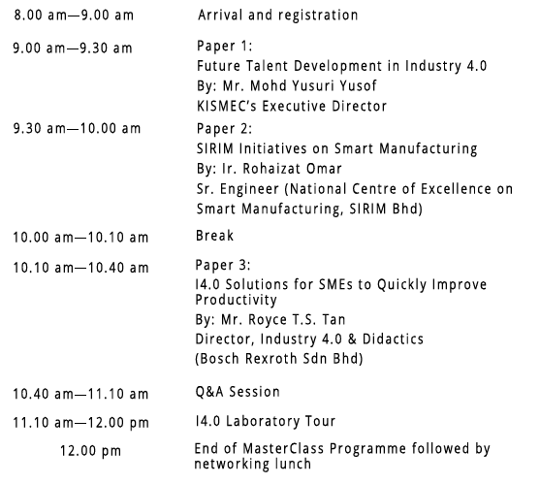
2.00 pm – 4.00 pm Meeting with KISMEC on Potential Collaboration on Upskilling
Existing Employees and COEs to share professional expertise and technologies

- Participants
Below are the names nominated to participate in Industry 4.0 MasterClass Programme at Kulim, Kedah.

    - Mr. Tiong Khe Hock – WG1: Human Capital Development Leader
    - Mr. Chan Chee Tatt – WG1: Industry Productivity Specialist
    - Ms. Nor Zirin Ariffin – Director, QED
    - Dr. Mazlina Shafi’i – Senior Manager, DMO
    - Ms. Nor Halisa Mohd Halil, Manager, DMO
    - Mr. Abdul Rahman Kamis, Assistant Manager, DMO

- Cost
The total cost of the programme is RM 10,535.00. Detail costing is as follows:
No | Item | Cost per Pax | No. of Pax | Total  (RM)
 | Logistic and accommodation:  - Flight  - Accommodation (2nights) | 500  450 | 4  6 | 2,000  2,700
 | Ground Transportation | 1000 |  | 1,000
 | Bayaran Perkhidmatan Pakar (1 day)  (Including travelling and transportation costs) | 2300 | 2 | 4,600
 | Allowance / Claim  Gred 54 – Meals RM85 x 1 day  Gred 48-52 - Meals RM60 x 1 day  Gred 41-44 – Meals RM45 x 1 day | 85  60  45 | 85  1  2 | 85  60  90
Total |  |  |  | RM 10,535

- Conclusion
The approval of BOM is sought to approve the programme and budget of RM10,535.00 for M&E Productivity Nexus to visit KISMEC Kulim on 25 June 2019.

  Prepared by:  Nor Halisa Mohamad Halil | Approved by:    Dr. Mazlina Shafi’i
Project Manager  Date: 14 June 2019 | Programme Manager  Date: 14 June 2019

