EXECUTIVE SUMMARY

TITLE |  | Appointment of Koperasi MPC Berhad to carry out a project entitled “Enforcing Contracts: Solicitors’ Fees - Moving Forward”
DATE & VENUE |  | March 2019 till July 2019  Venue: Launch - Kuala Lumpur,  State Bar Committees – Johor Bahru, Penang, Kuantan, Kuching, Kota Kinabalu
OBJECTIVES |  | To obtain data from members of the Bar all over Malaysia on actual solicitor’s fees charged for the scenario in the Case Study from the World Bank.
OUTPUT |  | To produce the data in written form as a guide/ best practice (guidebook).
PROJECT COORDINATOR |  | Koperasi MPC Berhad
TOTAL COST |  | RM150,000.00 (Koperasi MPC Berhad)  RM92,000.00 (Administrative cost)
BUDGET |  | Productivity Nexus Professional Services
RECOMMENDED BY
COMMENT/SIGNATURE BY PCT

MALAYSIA PRODUCTIVITY CORPORATION
INFORMATION PAPER FOR BOARD OF MANAGEMENT

TITLE: APPOINTMENT OF KOPERASI MPC BERHAD TO CARRY OUT A PROJECT ENTITLED “ENFORCING CONTRACTS: SOLICITORS’ FEES - MOVING FORWARD”

- PURPOSE

The purpose of this paper is to get approval from the Board of Management (BOM) to appoint Koperasi MPC Berhad to carry out this project which has been approved through Keratan Minit Bil. 186/2019 dated 13th Feb 2019 with the budget allocation of RM242,000.00. Koperasi MPC Berhad will be granted with a total of RM150,000.00 for the professional fees while the administrative cost will be RM92,000.00.

- BACKGROUND

2.1 The WBG’s Doing Business Report is annually issued and the Government of Malaysia is keen to identify and prioritize reforms in certain regulatory areas highlighted in the said Report. Amongst the regulatory areas that are being addressed includes “Starting a Business, Dealing with Construction Permits, Getting Electricity, Registering Property, Getting Credit, Protecting Minority Investors, Paying Taxes, Trading Across Borders and Enforcing Contracts”.

2.2 Amongst the key indicators identified under Enforcing Contracts that needs improvement would be “Time required to Complete Procedures, Cost required to Complete Procedures and the Number of Procedures”. This proposal concerns only on Solicitors Costs for enforcing contracts.

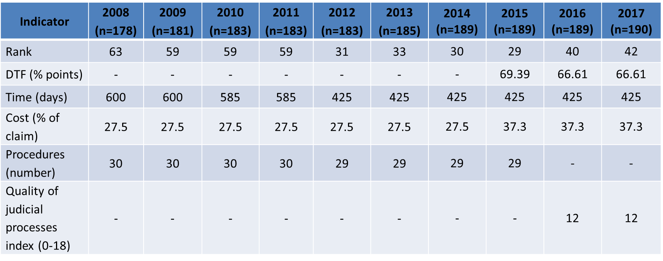

2.4 The cost for enforcement of contracts encompasses: (i) “fixed” court expenses such as filing fees; and (ii) solicitors’ fees which are discretionary depending on multiple factors such as the type of courts handling the claim, the seniority of the lawyer handling the claim, the size and reputation of the firm as well as the solicitor handling the claim amongst other factors.

2.5 There would not any marked improvements concerning the indicator “solicitors fees” due to the existence of anti-competition laws in Malaysia (the fixing of legal fees by any means other than statutory means – eg the Solicitors Remuneration Order applies for conveyancing transactions), the nature of a litigation case being a contentious matter, the Malaysian Bar being an independent self-regulated Statutory Body that would not want to impose any such limitations to its own members on such matters unless and until realistic steps are taken to persuade WBG that positive steps have been undertaken to improve this particular indicator.

- OBJECTIVE
3.1 To conduct and organize a series of talks/seminar throughout selected State Bars within the Malaysian Bar and Sabah and Sarawak for an all-encompassing objective of:
- Creating awareness amongst lawyers concerning the initiatives of PEMUDAH, MPC and THE World Bank Group and to impart knowledge about legal work for relating to foreign investments into Malaysia;
- Collection of data – same scenario in WBG’s Case Study can be used for an interactive session with lawyers and the input collected as data; and
- The collected data is to be processed and presented through a written chapter. It is proposed that it be included in any publication by MPC or PEMUDAH as a source of reference and benchmark.

3.2 The persuasiveness of a published report would have an influence on the respondents answering WBG’s Case Study questions in a more reasonable and fair manner.

- SCOPE

  - The project will be implemented by organising a series of talks throughout locations of selected State Bars within the Malaysian Bar, Sabah Law Association and Advocates Association of Sarawak whereby data can be collected concerning actual solicitor’s fees charged for the scenario in the Case Study from the World Bank. The consultant shall develop a questionnaire to be distributed during each session to get feedback from participants.

  - The invitation of participants will be made by consultants directly through Malaysian Bar/ States Bar and the target will be 50-60 legal practitioners per session.

4.3 The proposed Talks/ Seminars shall be at the following locations:
No. | Locations | Dates in 2019
1. | Kuala Lumpur | March
2. | Penang | April
3. | Pahang | April
4. | Johor Bahru | May
5. | Sarawak | May
6. | Sabah | June

4.4 The Project Consultants shall liaise with the Continuing Practice Development (CPD) Committee under the Bar Council to obtain accreditation for CPD points for members of the Bar and liaise also with the Sabah Law Association as well as the Advocates Association of Sarawak to arrange for the talks to be held at the respective States within Malaysia.

4.5 As CPD points are allocated to lawyers within hourly limits, we would like to propose a two (2) hour talk with a maximum of three (3) speakers. The ultimate objective would be to allow for enough time for participants to complete the Case Study questions over and above listening to the talks that are beneficial to them.

4.6 The proposed speakers should preferably be:
- One (1) speaker either from WBG / MPC / Project Consultants to introduce the Governments’ initiatives with the Case Study questions & collection of data;
- One (1) speaker with sufficient standing on international trade to speak about legal work opportunities either from MATRADE / the Business sector; and
- One (1) Bar Council member or lawyer that can speak about how to handle international and cross border work.

4.7 The stakeholders which will be involved are:
- Pejabat Ketua Pendaftar Mahkamah Persekutuan Malaysia (PKPMP);
- Kementerian Perdagangan Dalam Negeri dan Hal Ehwal Pengguna (KPDNHEP);
- Malaysia External Trade Development Corporation (MATRADE);
- Malaysia Competition Commission (MyCC);
- Malaysian Bar; and
- States Bar.

4.8 The outcome of this project will be a guidebook on professional legal fees to be launched by Yang Berbahagia Datuk Muez Bin Abd. Aziz, Secretary General of KPDNHEP.

4.9 The project timeline is as follows:
No. | Activities | March | April | Jun | July
1. | Survey development, data gathering and inception report  - Project launching at Kuala Lumpur (Series 1)
2. | Data analysis and interim report  - Penang (Series 2)  - Pahang (Series 3)  - Johor (Series 4)  - Sarawak (Series 5)
3. | Submission of final report (draft)  - Sabah (Series 6)
4. | Final report submission and presentation to stakeholders

- ESTIMATED EXPENSES

5.1 The estimated cost for this project are:
- The Project Consultants’ Fee RM150,000.00
- Administrative Cost RM92,000.00
(Refer Appendix 1)

5.2 Payment to consultants will be made as follows:
- Phase 1 (30%): After completion of data gathering and data analysis;
- Phase 2 (30%): After inception report and interim report are received; and
- Phase 3 (40%): After completion of the Guidebook for Attorney fees.

- APPROVAL OF BOM

The approval of BOM to appoint Koperasi MPC Berhad to carry out this project will require a budget of RM150,000.00 while the administrative cost will be RM92,000.00. Total cost for this project will be RM242,000.00 (Keratan Minit Bil. 186/2019 dated 13th Feb 2019).
Appendix 1
Estimated budget
- Professional fees
Phase | Total (RM)
1 | 45,000.00
2 | 45,000.00
3 | 60,000.00
Total (RM) | 150,000.00

- Administrative cost
Item | Cost (RM) | Total (RM)
Seminar Package (Food & beverages @ 6 states @ 50 pax) | 80.00 | 24,000.00
Accommodations  (5 states@ 1 night per state@ 5 persons) | 300.00 | 7,500.00
Flight (RM1,300 returns@5 states@ 5 persons) | 1,300.00 | 32,500.00
Honorarium for speakers  (6 seminars @ 2 speakers @ 1 hr) | 500.00 | 9,000.00
Printing (500 copies) | 30.00 | 15,000.00
Writer (20 pages) | 100.00 | 2,000.00
Proof reading (20 pages) | 100.00 | 2,000.00
Total (RM) |  | 92,000.00

