EXECUTIVE SUMMARY

TITLE | : | THE IMPLEMENTATION OF MACHINERY & EQUIPMENT PRODUCTIVITY NEXUS PROJECTS FOR 2019
PROPOSED DATE | : | January – December 2019
BUDGET/COST | : | RM 1,608,900.00 (SPN)
OBJECTIVES | : | To seek approval to utilise SPN budget for the implementation of Machinery and Equipment Productivity Nexus 2019 projects.
OUTPUT | : | Six (6) main MEPN sub-initiatives driven by four initiatives under MPB
DEPARTMENT | : | DMO / Machinery & Equipment Productivity Nexus
COMMENTS/
SIGNATURE OF ACCOUNTANT
COMMENTS/
SIGNATURE OF PCT MGR

PAPER FOR BOARD OF MANAGEMENT APPROVAL

Title: THE IMPLEMENTATION OF MACHINERY AND EQUIPMENT PRODUCTIVITY NEXUS PROJECTS FOR 2019

- Purpose
The purpose of this paper is to seek for the approval of MPC’s Board of Management (BOM) to utilise the Sectoral Productivity Nexus (SPN-M&E) budget for the implementation of projects in 2019.

2.0 Background
Machinery & Equipment Productivity Nexus (MEPN) implementation plan for 2019 – 2020 has been developed and relevant projects have been identified in line with the initiatives outlined in the Malaysia Productivity Blueprint (MPB).
Initiatives under the MEPN are as follows:

M1: | Set up partnership between government and industry associations to up-skill existing employees
M2: | Set up Centre of Excellence for skilled professionals to share industry expertise and develop new technologies
M3: | Set up more product testing facilities to ensure standards are met
M4: | Update of domestic product standards to be at par with international standards and enforce compliance

The Nexus has set up 4 work groups to identify relevant projects/sub-initiatives and detail out their respective implementation plans for 2019-2020 which are aimed at achieving the original sectoral initiatives described in the MPB. Fourteen (14) sub-initiatives have been identified to be implemented in 2019 to 2020. The details are in Appendix 1.

Four Leaders and four Subject Matter Experts have been appointed in each of the work group. While the members are selected from relevant stakeholders with strong support from MITI. The details of the structure are as follows:

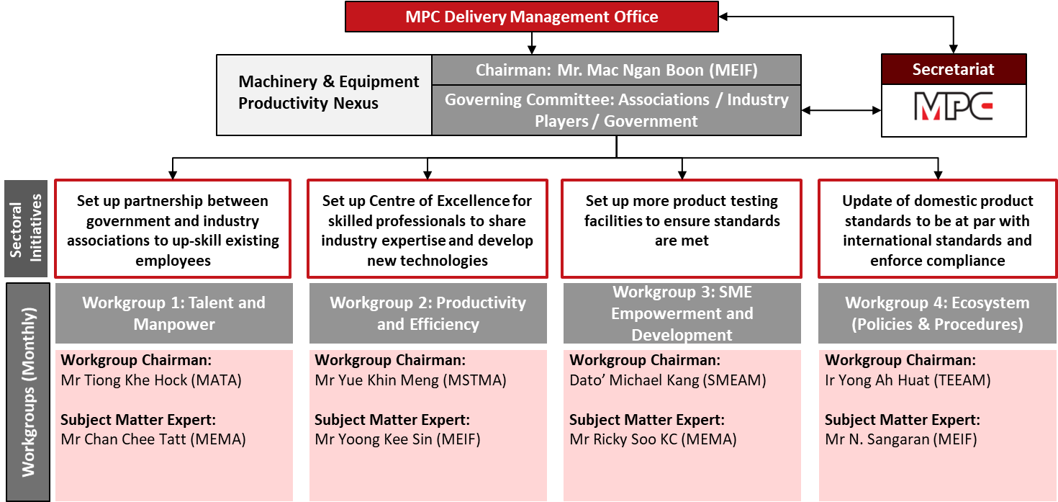

- Cost
Of the 14, six projects (sub-initiatives) have been identified to be undertaken in 2019 together with three project under MPC as well as administrative costs as follows:
No. | Projects (Sub-initiatives) | Estimated Cost (RM) | Quantity |  | Total Estimated Cost (RM)
 | PROPOSED PROJECTS
1 | M1.1 University-Industry partnership for M&E Talent Development | 500,000.00 | 1 | 500,000.00
2 | M1.4 Development of a web-based one-stop center for Human Capital Development | 200,000.00 | 1 | 200,000.00
3 | M2.1 Create targeted awareness programmes and leverage on existing MPC productivity tools and Govt grants to improve productivity | 36,000.00 | 5 | 180,000.00
4 | M2.2 Optimising functions of COEs through effective partnerships | 110,000.00 | 1 | 110,000.00
5 | M3.1 Industry Association-led efforts to enhance SME capabilities by leveraging on product testing facilities & Industry 4.0 funds, and cluster SME members for joint proposals to export products | 100,000.00 | 2 | 200,000.00
6 | M4.1 Emphasis on procurement to be based on compliance to export quality standards to elevate Malaysian SMEs capabilities | 100,000.00 | 1 | 100,000.00
 |  | TOTAL (A) |  | 1,290,000.00
 | PROJECTS UNDER MPC
1 | Integrated Communication Plan | 15,000.00 | 1 | 15,000.00
2 | Best Practices (5 cases) | 2,500.00 | 5 | 7,500.00
3 | Capacity Building on M&E Ecosystem | 15,000.00 | 1 | 15,000.00
 |  | TOTAL (B) |  | 37,500.00
 | ADMINISTRATIVE COST
1 | PSH @ RM4,500 / month x 12 months | 54,000.00 | 1 pax | 54,000.00
2 | Mileage claim @ RM2,000 / month x 12 months | 2,000.00 | 12 months | 24,000.00
3 | Promotion materials | 32,000.00 | 1 | 32,000.00
4 | MEPN Advisor cum Coordinator @ RM7,000 / month x 11 months | 7,000.00 | 11 months | 77,000.00
5 | NGC Meeting RM15,600 x 4 sessions | 15,600.00 | 4 sessions | 62,400.00
6 | Working Group Meeting @ RM2,000 x 4sessions x 4 WGs | 8,000.00 | 4 WGs | 32,000.00
 |  | TOTAL (C) |  | 281,400.00
 | OVERALL TOTAL (A) + (B) + (C) |  |  | 1,608,900.00
Cost estimation was planned based on MEPN Implementation Plan 2019-2020 developed in 2018.

- Conclusion

The approval of BOM is sought to approve the Budget of RM1,608,900.00 for the implementation of six sub-initiatives and other MEPN projects in 2019 under Machinery & Equipment Productivity Nexus.

  Prepared by:  Nor Halisa Mohamad Halil | Approved by:    Dr. Mazlina Shafi’i
Project Manager  Date: 29January 2019 | Programme Manager  Date: 29 January 2019

APPENDIX 1
All fourteen (14) sub-initiatives proposed for 2019 and 2020 will address systematic concerns across the Machinery and Equipment value chain including engineering services as the followings:
FOURTEEN (14) SUB-INITIATIVES TO BE IMPLEMENTED IN 2019 TO 2020
INITIATIVE | SUB-INITIATIVE | PROPOSED KPI 2019
M1: Set up partnership between Government and industry associations to upskill existing employees | M1.1: University-Industry partnership for M&E Talent Development | M1.1a. 2 LOI/MOUs to be established
 | M1.2: Encourage more industry-driven apprenticeship programmes via the Nexus and recognition for industry champions which deliver | M1.2a. Number of companies involve in collaboration with the selected TVET institution
 | M1.3: Upskilling existing employees and trainers through partnership between industry and TVET | M1.3a. Ten instructors trained  M1.3b. Revised curriculum (fundamental M&E skills)  M1.3c. 50 employees trained (companies contributed to HRDF)
 | M1.2: Development of a web-based one-stop center for Human Capital Development | M1.2a. User requirements and appointment of consultant
M2: Set up Center of Excellence for skilled professionals to share industry expertise and develop new technologies | M2.1: Create targeted awareness programmes and leverage on existing MPC productivity tools and Govt grants to improve productivity | M2.1a. 300 companies utilised the MPC tools  M2.1b. 400 companies aware of the industry 4.0 & the need for productivity
 | M2.2: Optimising functions of COEs through effective partnerships | M2.2a. 5 companies partake in the SIRIM Industry 4.0 programme
M3 Set up more product testing facilities to ensure standards are met | M3.1: Industry Association-led efforts to enhance SME capabilities by leveraging on product testing facilities & Industry 4.0 funds, and cluster SME members for joint proposals to export products | M3.1a. 200 SMEs registered with the M&E Industry Associations
 | M3.2: Development of a comprehensive repository of the M&E supply chain to encourage development of end-to-end solutions | M3.2a. 1,000 M&E companies
M4: Update of domestic product standards to be at par with international standards and enforce compliance | M4.1: Emphasis on procurement to be based on compliance to export quality standards to elevate Malaysian SMEs capabilities | M4.1a. Final proposal submitted by 2019
 | M4.2: Streamlining of targeted processes and regulations on a prioritised basis | M4.2a. 2 processes streamlined and improved by 2019
 | M4.3: Govt to re-include Industry Associate representatives into key Approval committees for Govt incentives to build up agency knowledge and familiarity | M4.3a. Subject Matter Expert in Industry 4WRD panel
 | M4.4: Improvement to the SST regime to encourage in-country value-add activities | M4.4 &4.5a. Final proposal on SST improvement by 2019
 | M4.5: Streamlining of import duties to encourage in-country value-add activities | M4.4 &4.5a. Final proposal on SST improvement by 2019
 | M4.6: M&E companies to be required to be industry association members to qualify for Govt incentives | M4.6a. Final proposal submitted by 2019  M4.6b. 50 Companies sign up under Industry Associations
